**Network Virtualization Concepts**

Self-Paced Microcourse





At the end of the course, you should be able to

* articulate NSX capabilities and benefits
* describe the major VMware NSX® components in the data, management, and control planes and their interactions
* apply relevant NSX features to use cases
* explain NSX network virtualization components and services
* explain how network virtualization is utilized in an SDDC environment

**Module 2: Introduction to Network Virtualization**

NDG - Network Development Group

**VMware** is a cloud computing and virtualization software provider for X86 or IBM compatible computers and servers. ... With **VMware** server virtualization, a hypervisor is installed on the physical server to allow for multiple virtual machines (VMs) to run on the same physical server.

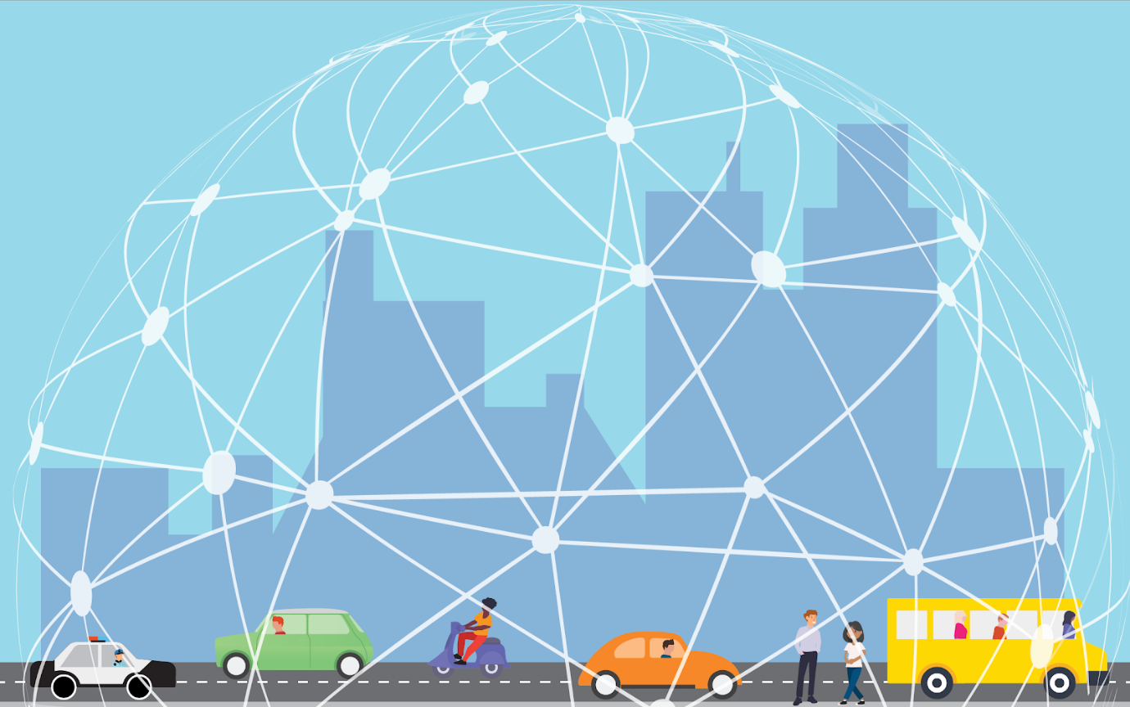

A 5G world has virtualization at its core. As the number of out connected devices mushrooms from the hundreds of millions to the tens of billions, data centers are relying more and more on virtualized infrastructure to handle the tsunami of data that we're producing and consuming. And it's not just data centers: the fact that 100% of the Fortune 100 companies use virtualization (and VMware virtualization technology at that), tells its own story.

In the Software-Defined Data Center (SDDC), compute, networking, and storage infrastructure is virtualized so that resources can be pooled and used more efficiently, less expensively, and faster. Real strides have been made in server (compute) virtualization and are increasingly being seen with storage virtualization.

The efficiencies gained from them, however, have been limited to a certain extent by legacy, (i.e, traditional, non-virtual) network infrastructure that's still reliant on physical hardware and mainly manual processes. While an organization's virtualized compute and storage may be dynamic, agile, and flexible, its legacy networking just can't keep up. And an infrastructure or organization that can't keep up often gets left behind.

Network virtualization enables the speed, mobility, and security, needed in a 5G world. Infrastructure can be made ready for new applications or be changed in minutes, rather than days or weeks. Apps and workloads are no longer restricted to individual physical subnets, neither are switches, routers, firewalls, etc. The security focus moves from simply protecting the perimeter (the *outside* surface) of a data center's infrastructure to providing the ability to give each virtual machine and virtual network its own firewall, shifting the focus to the *inside* perimeter of the data center and reducing the attack surface. In addition, virtual networks are isolated. and (as we will learn later in this course) segmented from each other and from the underlying physical infrastructure so that threats cannot be spread if they do get in.

Network virtualization extends these features and many others to the cloud as well, a critical factor to the 81% of enterprises that now use multiple cloud deployment models.

## What is Network Virtualization?

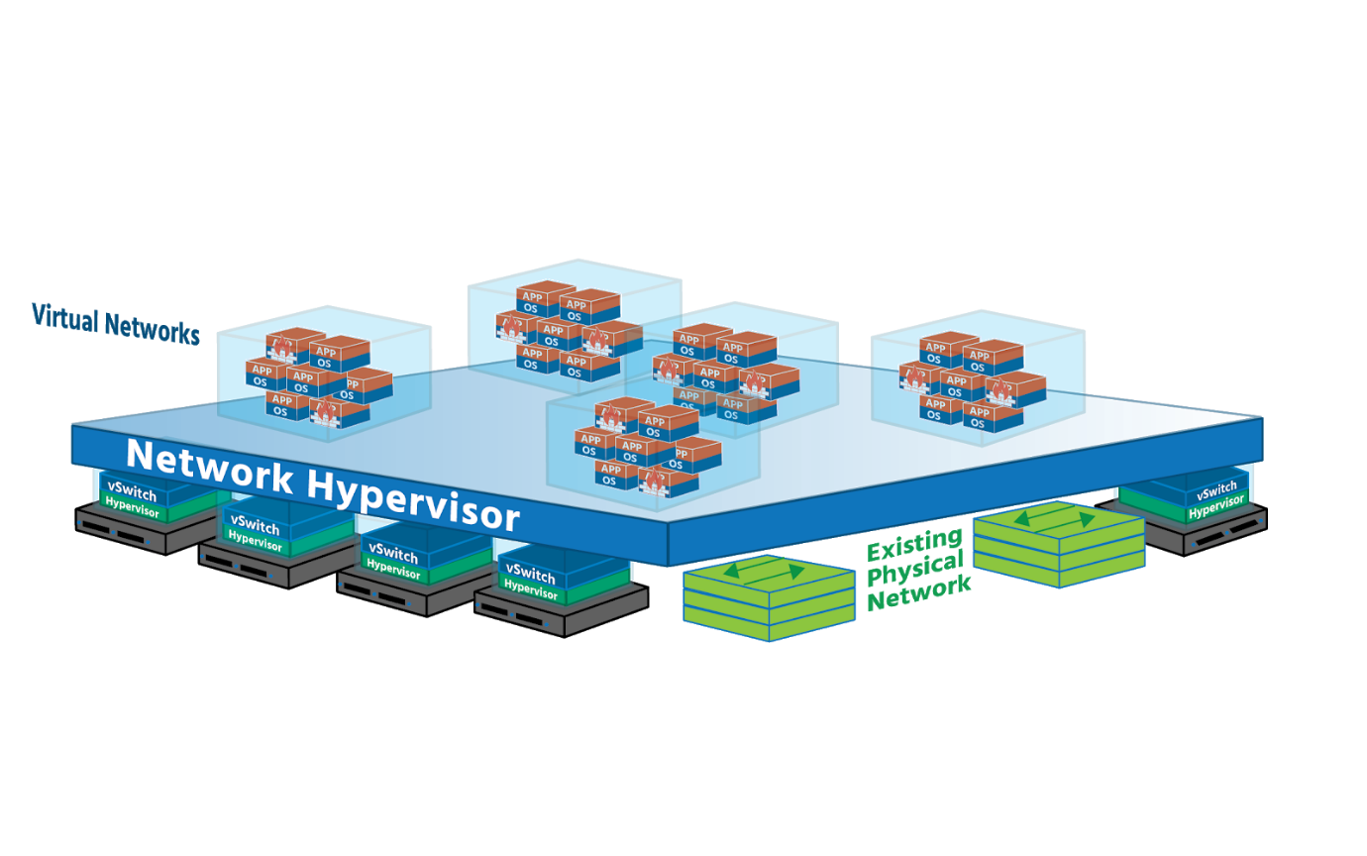

Network virtualization totally separates network resources from physical hardware by recreating those networking resources in software- by virtualizing them. Physical routers (which forwards data across multiple networks,) switches (which forwards data on a single *Local Area Network* or *LAN*) and load balancers (which even out workloads to prevent servers from being overwhelmed) are virtualized in the hypervisor layer using off-the-shelf, industry-standard servers (server/compute hosts). This virtualized pool can then be used as needed, on-demand. The underlying physical hardware remains important (it's still used for forwarding) but no longer needs to be reconfigured every time a new VM or container is added or updated, or every time a device on the network is moved to a different part of the network. The whole network can now be run in software.

This hypervisor-based networking software (which will include security services as well) uses a **controller** to send network services to virtual switches and *attaches* the services to individual *virtual machines (VMs)* and containers. The result is a virtual network (The exact services will be determined by the policies already assigned to the VM/containers.). In this virtual network, whenever new VMs and containers are created, the appropriate policies are automatically applied to them, and when VMs and containers move, their networking and security move with them. (You'll sometimes hear VMs and containers referred to as *workloads*, so we'll use that term here to familiarize you with it.)

Creating a virtual network on top of a physical network is known as **overlay networking**. Imagine two devices (or *endpoints*) on an organization’s network – *Finance Department Laptop* and *Sales Department Laptop*, for example, both connected to physical network ports. (VMs and containers can be *endpoints*, too.) Both laptops are given a virtual network ID (*VNID*) and assigned to a virtual network. Virtual switches then connect *Finance Department Laptop* to *Sales Department Laptop* via virtual links (software representations of physical links) that form a tunnel across the network. Each virtual link corresponds to a path in the underlying physical network.

Network virtualization works just as well in the cloud and can be managed by using a Cloud Management Platform (*CMP*) such as *VMware’s vRealize Automation* or an open-source option such as *Apache CloudStack* and *OpenStack*. Hypervisor-based network virtualization can be set up and run using a Graphical User Interface (*GUI*) and a Command-Line Interface (*CLI*) or using Application Programming Interfaces (*APIs*).

Network virtualization provides administrators with tremendous flexibility. It can be used for networks as small as two connected devices, or as large as networks spanning multiple sites of major enterprises. In addition, it is flexible enough to work with any cloud or cluster (or pod if you’re using a new application framework like *Kubernetes*) while having different virtual networks that can be associated with different workloads. **VMware’s NSX for vSphere** (NSX-V) virtual network and security product works with ESXi (a Type 1 hypervisor - i.e., one that runs directly on the host’s hardware, independent of the host’s operation system), while their **NSX-T Data Center** works with ESXi and with KVM (a Type 2 hypervisor running within the host’s operating system).

Virtual networks are not to be confused with *virtual local area networks* – VLANs. A VLAN takes the ports of a physical switch and groups (or isolates) them to fit a specific purpose. An organization might have its Finance Department on the first floor, HR on the second and third, Production on the fourth, Sales on the fifth, and printers scattered around the building. On one physical switch, five VLANs could be created for these separate functions, each with its own *broadcast domain*.

.

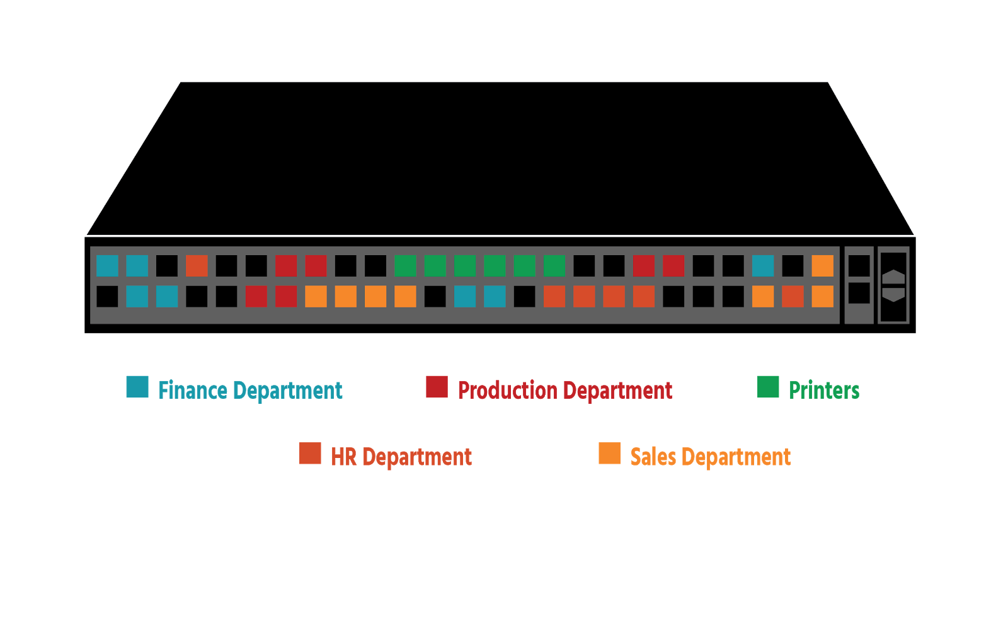

However, only a maximum of 4096 VLANS can be created on a Layer 2 (*Data Link Layer)*network. (This is a reference to the **OSI networking model**, which has 7 layers that together describe the different communication functions of a networking system.) This may seem like a lot, but imagine being a company that gave each of its customers 5 VLANS: after customer 819 you would have no more VLANS – which would mean no new customers. Security is an issue since VLANs are separated from a logical perspective but are actually running through the same connection, and a security breach on one can affect them all. And every time a VLAN is extended, a time-consuming physical configuration is needed.

With network virtualization, on the other hand, network services beyond data transfer are also available – switching, routing, firewalling, and load balancing (Layer 3 to Layer 7 functions). The network in its entirety (Finance, HR, Production, Sales, and printers) can be recreated in software in seconds, and cloned or moved if needed; or *snapshots* representing the exact state of a network at a particular point in time can be created, saved, and used to recreate the network if required. Every networking and security service is virtualized (handled in software) and attached directly to individual workloads, reducing the need for physical configuration.

What is Software-Defined Networking?

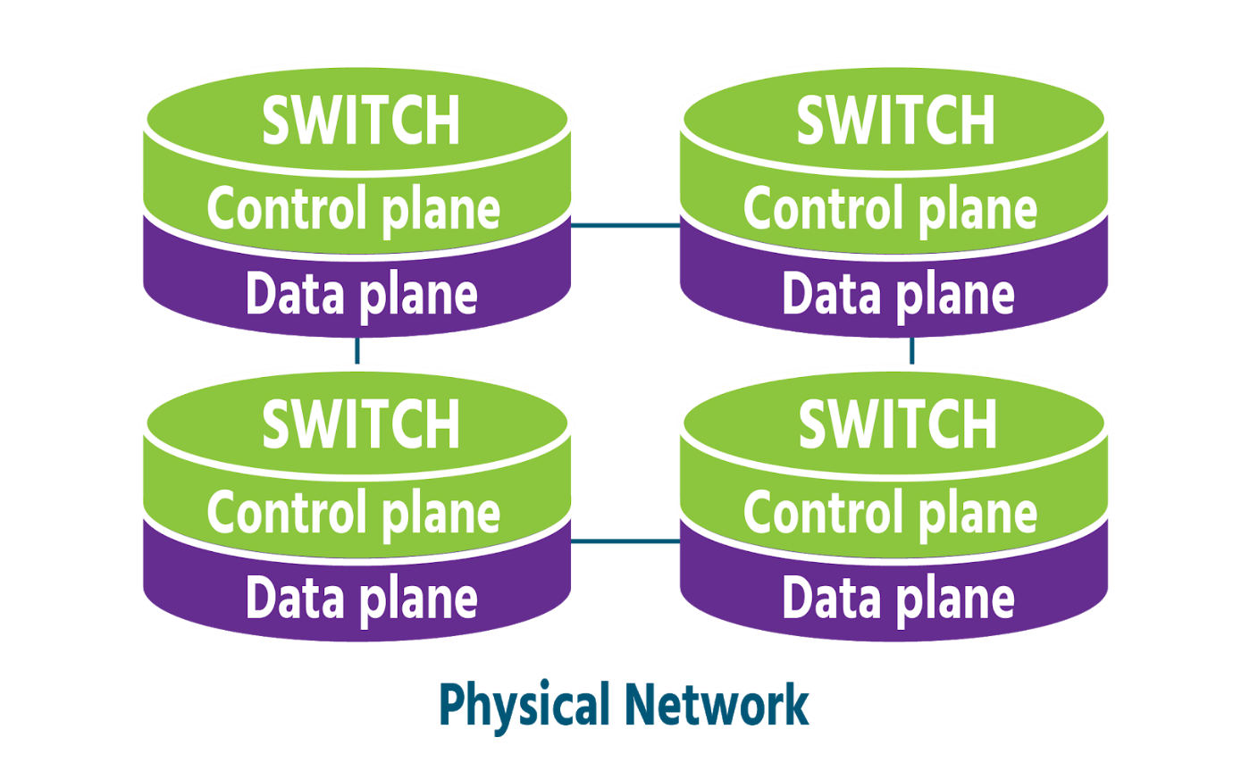

Network virtualization and *Software-Defined Networking (SDN)* stem from a common pursuit- the goal of greater network agility- and still share certain traits:

* Both use software to recreate key components of networking infrastructure
* Both separate the **control plane** (the part of the network that manages and controls it- a network's *brains*) from the **data plane** (the part where data traffic flows- a network's *muscles*) This means that with both network virtualization and SDN, network control can be programmed directly for applications and network services, without the need for manual configuration.
* Both use a **controller** that runs specialized software to centralize network management.
* Both (to varying degrees) fulfill the primary goal of increased agility by allowing administrators to quickly and precisely adjust the flow of data traffic across a network.

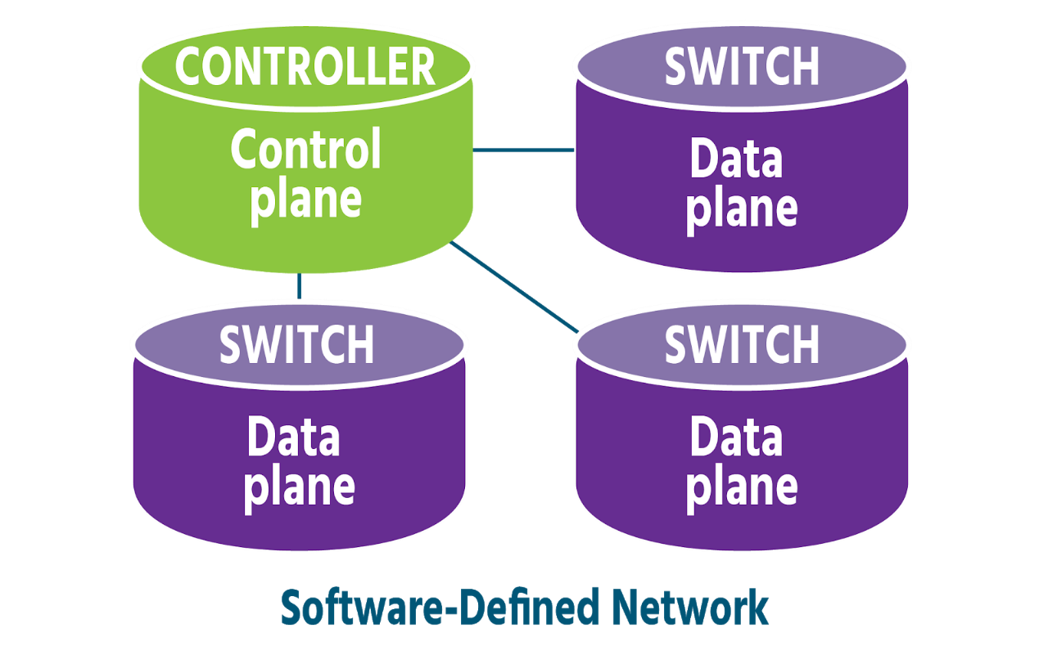

Over time, however, SDN has become more broadly-defined than network virtualization, meaning different things depending on who you speak to and how they are using SDN. The thread that links these different definitions is *SDN's use of software to control networks and their physical devices.* With SDN, software controls network switches and routers, but the network is not fully virtualized, as it is with network virtualization (components, configurations, functions, and all). Hardware often still plays a major role in an SDN network.

**Virtual Networks in Physical Networks**

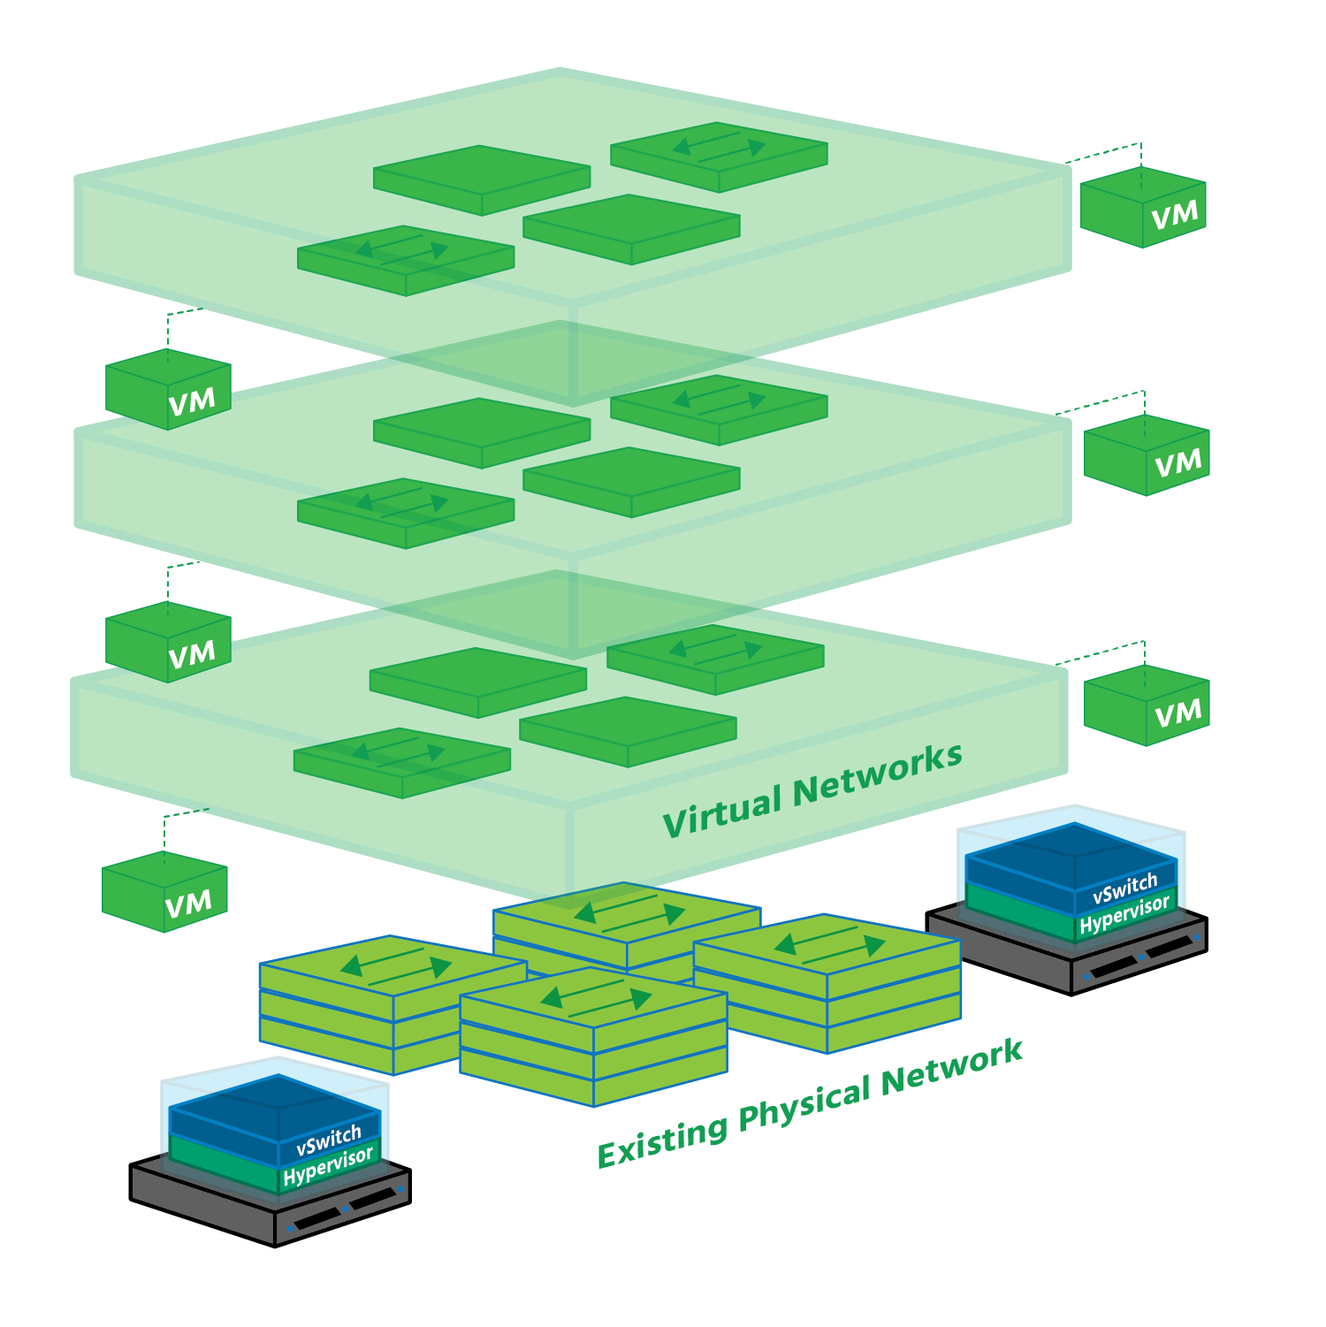

Network virtualization allows you to look at your current physical network from a fresh perspective, one in which you're no longer restricted to the capabilities of your hardware. Software vastly extends your range of possibilities, recreating your hardware as a virtualized pool that can then be used as needed, on-demand.

Imagine your physical network doubled in scope: your physical network is there doing the job it's always done, but in parallel with it you now have an identical virtual version running independently, alongside or on top of it. Once that virtual network has been created, it can be saved, closed, and restored later, possibly at another site. Or it can be deleted altogether.

Now imagine the scope of your physical network tripled, quadrupled, or more, because virtualization separates networking from the underlying hardware, you can create as many virtual networks (copies of the physical network) as you need. Each of these virtual networks runs in splendid isolation, unaffected by events in other virtual networks or in the data centre.

## Bridging Between Virtualized Networks and Traditional VLANs

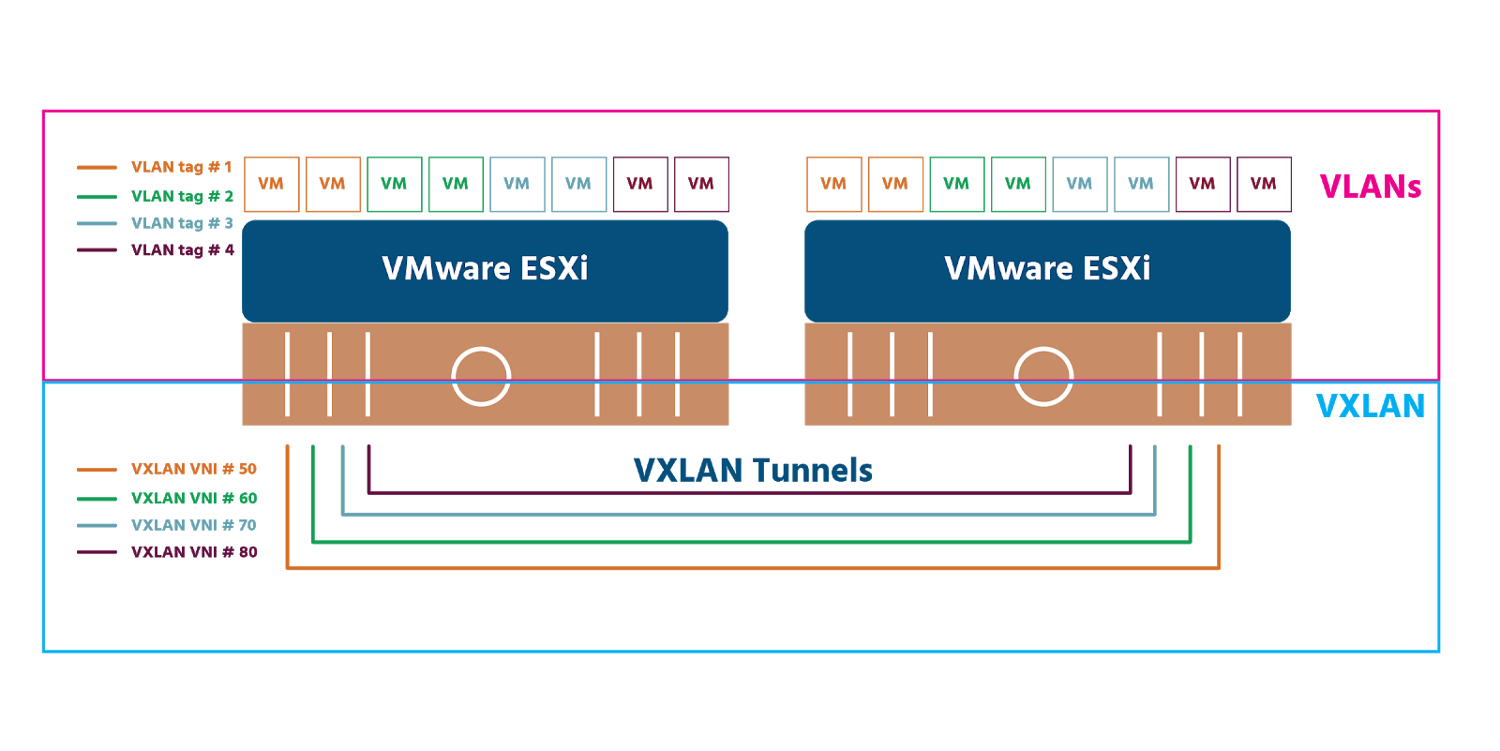

As we mentioned in section 2.1, creating a virtual network on top of a physical network is known as **overlay networking**. The underlying infrastructure becomes the underlay - also known as the physical (Layer 3) network. Several overlay methodologies exist. Two of the most widely-used are **Virtual Extensible Local Area Network** (VXLAN) and **Generic Network Virtualization Encapsulation** (GENEVE). It is important to note that VXLAN is vendor-neutral and has been recognized as RFC (Request for Comments) 7348, which is a formal document from the Internet Engineering Task Force (IETF).

VXLAN works on hardware (e.g., on routers or switches), on software (e.g., on a hypervisor) or on both (hybrid). It uses 24-bit binary identifiers (from 00000000000000000000 to 111111111111111111111111 and everything in between) meaning that a maximum 16,777,215 VXLANs are possible. Compare that to the maximum 4096 VLANs permitted by their 12-bit identifiers! A VXLAN ID is called a **VXLAN Network Identifier** (VNI). Each VNI is a separate virtual network that runs in the overlay network which are also known as **bridge domains**.

**VXLAN Tunnel Endpoints** (VTEPs) connect the physical network to the overlay network. Every VTEP has an IP address in the physical network and one or more VNIs in the overlay network. Encapsulated traffic (traffic that’s had certain information added to it at key stages of its journey - see section 4) is transferred between hosts via a stateless tunnel that is created between a source VTEP and a destination VTEP. By the time data from a host reaches a VXLAN switch, it’s in the form of frames, specifically “inner MAC frames” which include MAC (i.e., hardware) address information and data. The switches add a “VXLAN header” containing the 24-bit VNI.

The source VTEP then adds the IP address of the destination VTEP in an IP header, as well as its own IP address. It adds a **User Data Protocol** (UDP) header (UDP being the transport protocol that VXLAN uses). The MAC address of the next physical device that the frame will be delivered to on its journey is added in an Ethernet header. The physical network (the underlay) forwards the encapsulated frame on to the destination VTEP, which removes the headers in a process called **decapsulation** (mentioned again in section 4). The frame is then delivered to the destination host.

GENEVE is a relatively new entrant to the tunnel protocol field. It was jointly developed and drafted as an IETF proposal by Intel, Microsoft, Red Hat, and VMware and released in 2014. At the time this micro-course was written, GENEVE is currently going through the IETF process to become an RFC itself and so GENEVE is equally vendor-neutral. It works almost identically to VXLAN but is more flexible because it offers control plane independence between tunnel endpoints. And there’s a slight difference in terminology: GENEVE does not have VTEPs (VXLAN tunnel endpoints), just tunnel endpoints (TEPs).

It is important to note that NSX-V utilizes VXLAN overlay encapsulation, and NSX-T uses GENEVE.

# **Module 3: The Software-Defined Data Center**

## The Software-Defined Data Center (SDDC)

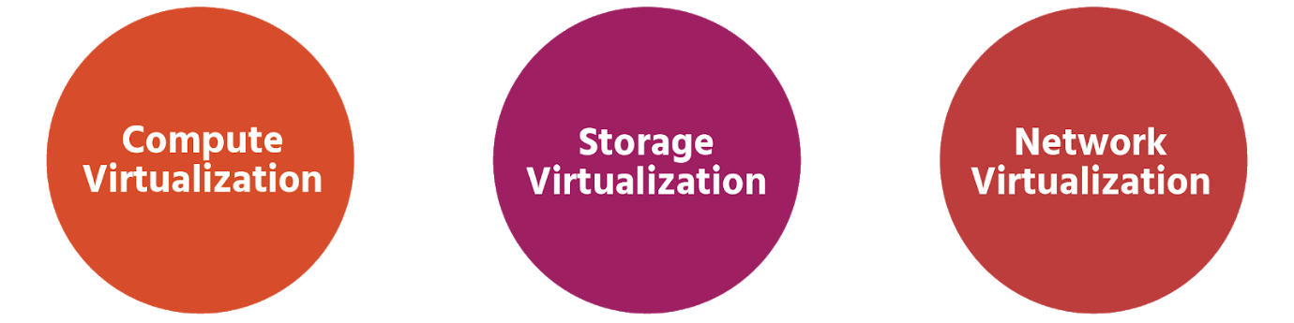

With 2.5 billion bytes of data currently being produced around the world every single day and the amount of data stored around the world doubling every two years, it's easy to see why data centres are growing in importance. It's also clear why increasing efficiency(in terms of systems and manpower) and safeguarding uptime (the number of systems that are running smoothly and available) are two of their highest priorities

Data centres have traditionally been 'hardware-centric" - focused and reliant on physical equipment. And this hardware has very often been made by vendors who charge a lot for the initial purchase(especially if the hardware has been custom-made), for maintenance and for the upgrades. This has not only been financially expensive but has also come at the cost of flexibility and agility in a rapidly-changing business landscape.

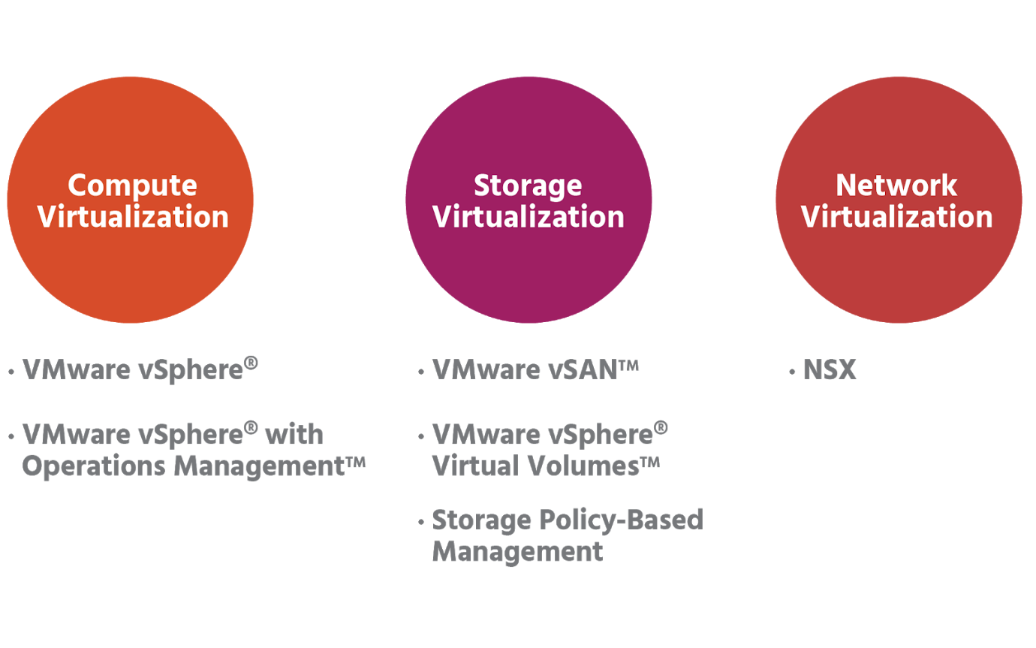

Thankfully all major services services in a data center can be virtualized. Pioneered by VMware, the **Software-Defined Data Center**(SDDC) extends virtualization beyond compute(i.e, servers) to network and storage as well. All data centre resources and services become software-defined.

Expensive vendor- specific hardware is replaced with affordable off-the-shelf industry-standard hardware. Because virtualized systems can be copied and saved, they can be easily be reproduced in the event of a system failure. And with automation, this reproduction can be almost immediate, meaning less downtime

In the software-defined data centre, the hypervisor is the controller. It pools together hardware resources which can be allocated precisely when and where they're most needed.

Management software that uses pre-defined policies vastly simplifies SDDC operations. All applications - wherever they're located - can be centrally monitored and managed. Different kinds of workloads (VMs or containers, for example) can be set up, run, and managed in different kinds of environment - physical, virtual, or cloud - using the same management software. And with automation, far fewer people are needed to do this.

## Physical Data Centres

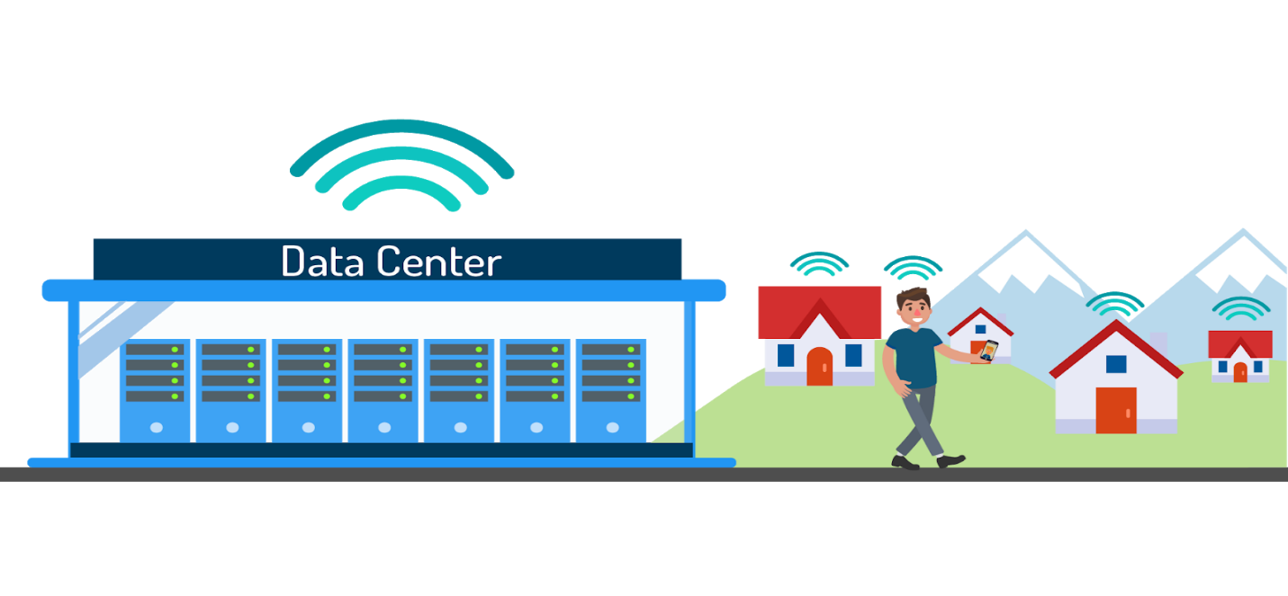

Every bit of information that you access on a device is the result of a transfer of data between where the information is processed and stored, and the device to which the data is sent. Whether you're searching for a good restaurant or the best price on a textbook, the information you find comes from a website that hosts its content in a data centre. Today, most people rely on the internet to get the majority of their information about the world around them, and most companies rely on it to reach a good proportion of their customers. This is why efficiency and agility in data centres are so vital.

Data centres are often presumed to be large warehouse-sized structures owned by a large corporation or a government, but they can also be set up on-site by small businesses and companies themselves. These data centres house computer systems, called servers, that are used to share or compute data for clients such as a smartphone user or a business website faster than a regular computer could.

Data centre infrastructure consists of three main components: compute systems (a server or host), storage devices, and networks. In a physical data centre, this will all be hardware, and massive amounts of it are needed for all the data currently in circulation. It was estimated in 2016, for example, that Google had 2.5 million servers at the time.

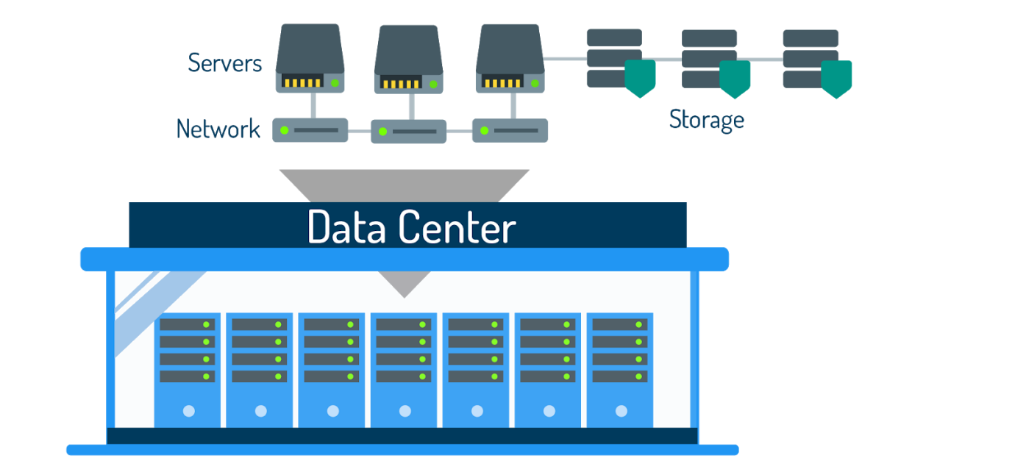

Effective management means monitoring data availability, capacity, and performance, and providing robust data security (as well as power management, effective cooling systems, and security measures).

As mentioned in the last section, physical data centres are inflexible. They’re also costly to maintain with multiple manual processes and disconnected operations. Even with compute and storage virtualization, applications are still linked to the physical network infrastructure. Without network virtualization, data centre operations will remain very manual, and therefore slow and expensive.

## Virtualized Data Centres

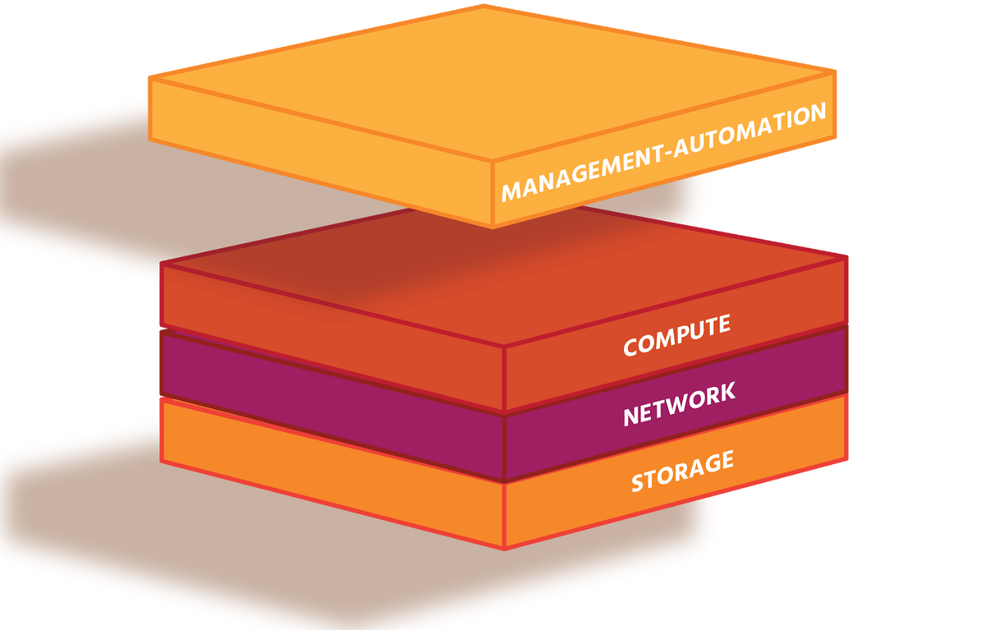

Software-defined data centres solve the problems of cost, complexity, inefficiency, and inflexibility posed by physical data centres. A fully-virtualized SDDC will encompass compute, storage, networking infrastructure and cloud management, making data centre services as inexpensive and as easy to configure and manage as virtual machines. Not only does the move away from vendor-specific hardware reduce purchasing and maintenance bills, but it also removes the need for costly training on how to use this highly-specialized and often custom-made hardware.

The main benefit of virtualization in the SDDC is the ability to gather physical resources such as CPU, memory, storage, and network I/O (data transfer from one device into another) into logical (i.e., non-physical) pools, which can then be allocated to individual VMs or containers (workloads).

The use of management and automation software means that these virtualized resources can be quickly provided when needed and adjusted as needs change. The use of policies (pre-defined rules) means that this can be done with consistency and precision. Automation has the further benefit of releasing highly-skilled staff from repetitive tasks into more productive, value-adding activities.

Information can be collected from the data centre environment (using, for example, VMware’s vRealize Operations Manager, which provides automated operations management for physical, virtual, and cloud infrastructures) and used to plan future capacity more accurately.

Network virtualization separates switches, routers, and network services from the underlying physical network. The network virtualization platform of VMware is NSX. It bridges the gap between physical networks and applications, reduces hardware complexity and costs, improves application availability (uptime) and speeds up system recovery.

VMware’s SDDC Approach

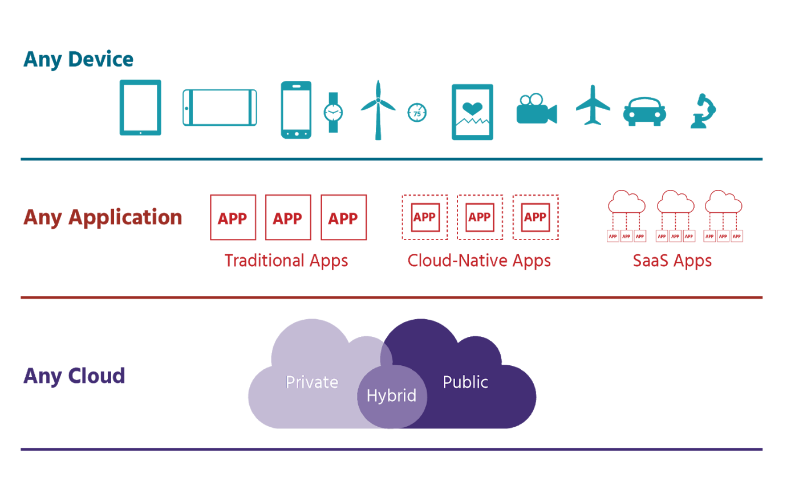

Software powers the growth and development of networks and data centre infrastructure. VMware is the creator of software-defined agility, with instant provisioning from the data centre to devices. Its technologies provide advanced security that is built into (or *native to*) applications, devices, and infrastructure, and seamlessly unify private and public clouds. Using the SDDC approach, organizations can meet their business demands efficiently and flexibly, while making long-term cost savings. VMware’s vSphere for server virtualization, vSAN for storage virtualization, and NSX for network virtualization are just some of the products that help their more than half-a-million customers achieve these benefits. (We’ll look at the *NSX Data Centre* in detail in section 5).

More and more organizations are choosing to mix and match their clouds to maximize the effectiveness of their spending and resourcing. Blending on-premises private clouds with public clouds is the most common mix, and the term used to describe this ‘best of both worlds’ approach is *hybrid clouds*. A hybrid cloud strategy is integral to VMware’s vision to help their customers use any cloud to deliver any application to any device. In addition, as the majority of businesses have yet to fully-virtualize their compute, storage, and network infrastructures, VMware technologies can be brought together in natively-integrated software sets (SDDC in-a-box). Sets (or *stacks* as they’re known) such as *VMware Cloud FoundationTM*, in turn, make deploying hybrid clouds much simpler. *Cloud FoundationTM* and *Cross-CloudTM* services (together known as *VMware’s Cross-Cloud Architecture*) support VMware’s hybrid cloud strategy.

VMware has partnered with *Amazon Web Services* (AWS) to offer *VMware Cloud on AWS* (SDDC as a Service), in which a single set of software tools can be used to manage both on-premises private clouds and public clouds. This approach combines both VMware’s and AWS’s extensive compute, storage, networking, and security capabilities in one flexible and easy-to-use service.

In a nutshell, here is why VMware thinks its SDDC offers what no-one else can:

* SDDC technology means more of an organization’s infrastructure can be used more of the time, in turn making their staff more productive, and greatly reducing spending on physical equipment (known as *capital expenditure* or CapEx) and on operating costs (OpEx).
* SDDC enables the deployment of applications in minutes or even seconds with policy-driven provisioning that matches resources to continually-changing workloads and business demands.
* SDDC makes possible the right availability, security, and compliance for every application.
* SDDC supports private, public, and hybrid clouds. In each case, the infrastructure is fully abstracted from applications so they can run on multiple sets of hardware, hypervisors, and clouds.

The result of a fully-virtualized SDDC is unprecedented IT agility and efficiency, with the flexibility to support today’s and tomorrow’s hardware and applications.

Data Centre Building Blocks

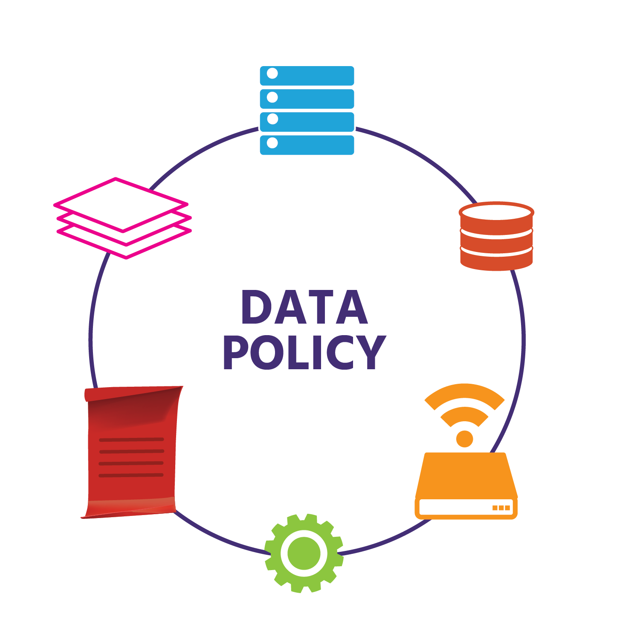

With all the components, no two data centres will be the same. However, some of the key components that an enterprise (i.e., large-scale) data centre will include are applications, servers, storage, networking infrastructure, management, and automation

As the role of virtualization in data centres increases, these key building blocks may look different. Currently, we’d expect a *fully-virtualized* data centre to:

* be software-defined: automated and managed by a single set of policy-based software tools that allow you to centrally monitor and administer all applications across different environments (physical, virtual, and cloud) and infrastructure types
* have built-in security
* be very easy to adjust in size – either *scaling out/in* by adding/removing devices, or by *scaling up/down* by adding/removing resources such as CPUs or storage to a single device
* support the latest developments in application technology, such as containers and apps specifically designed for the cloud
* support *infrastructure*as a code - i.e., support the writing of code that takes care of configuration and automates provisioning.

These building blocks will change as the SDDC grows and develops. Since the emergence of virtualization in the 1960s, with the likes of the Burroughs Corporation’s B5000 computer and IBM mainframe computers, it has changed the world. Servers have probably gone through the most innovation, with the tangible benefits including reduced physical complexity, increased operational efficiency, and simplified repurposing (i.e., virtualizing) of underlying physical resources. Today the vast majority of servers are virtualized and, in terms of networking, there are now more virtual ports being used globally than physical ones.

With an already-large range of products in data centre management and automation (*vSphere*, *vRealize*, and *NSX*, to name just three), VMware continues to innovate for its current and future customers.

# **Module 4: Network Virtualization Service**

## Network Virtualization Services

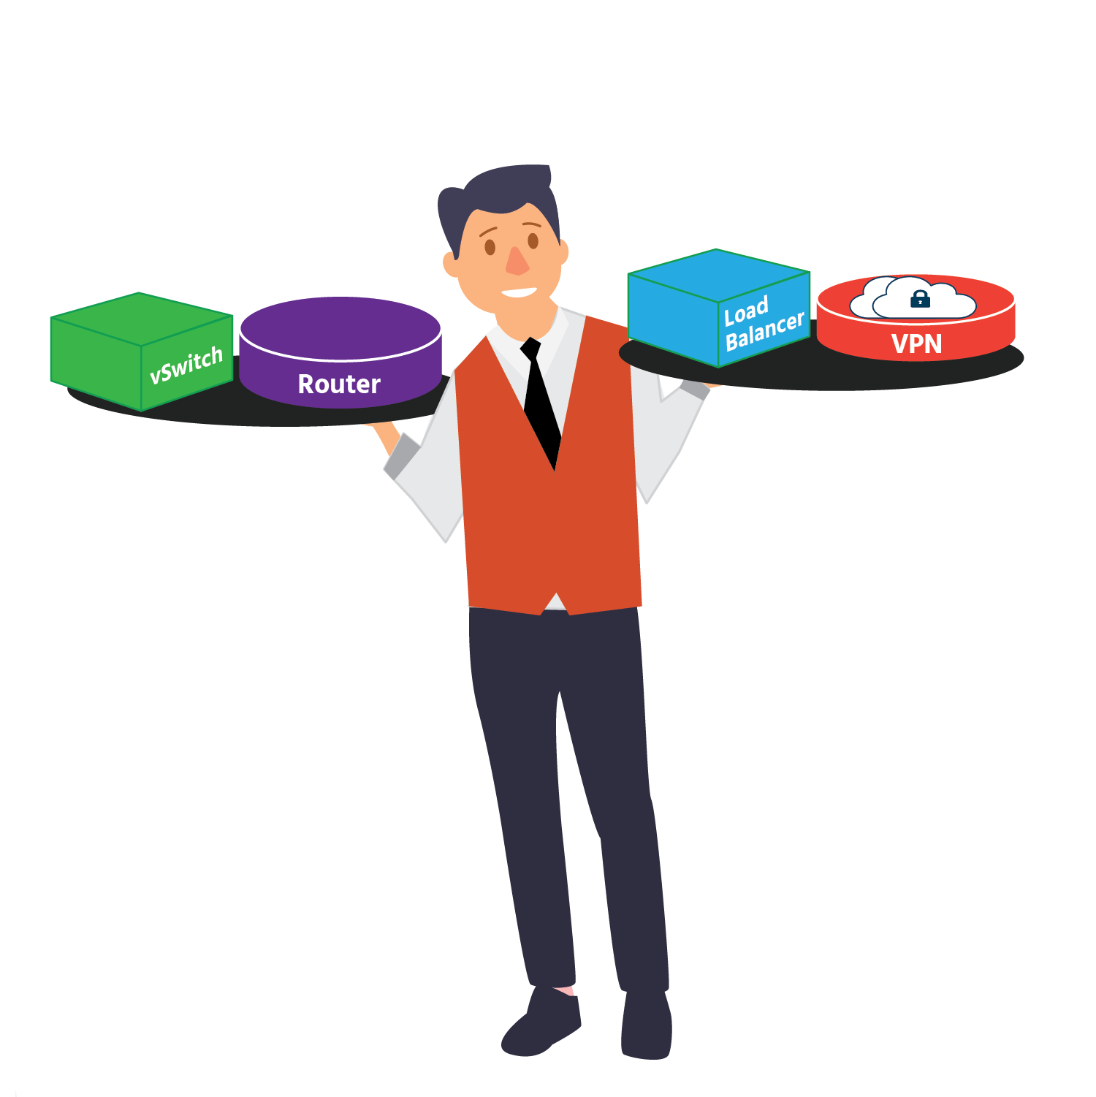

Before you look at network virtualization services, we think that a quick overview of the **Open Systems Interconnection** (OSI) model might be helpful.

In this 7-Layer network model, data is transferred from Host A to Host B in segments, packets, frames, and bits.

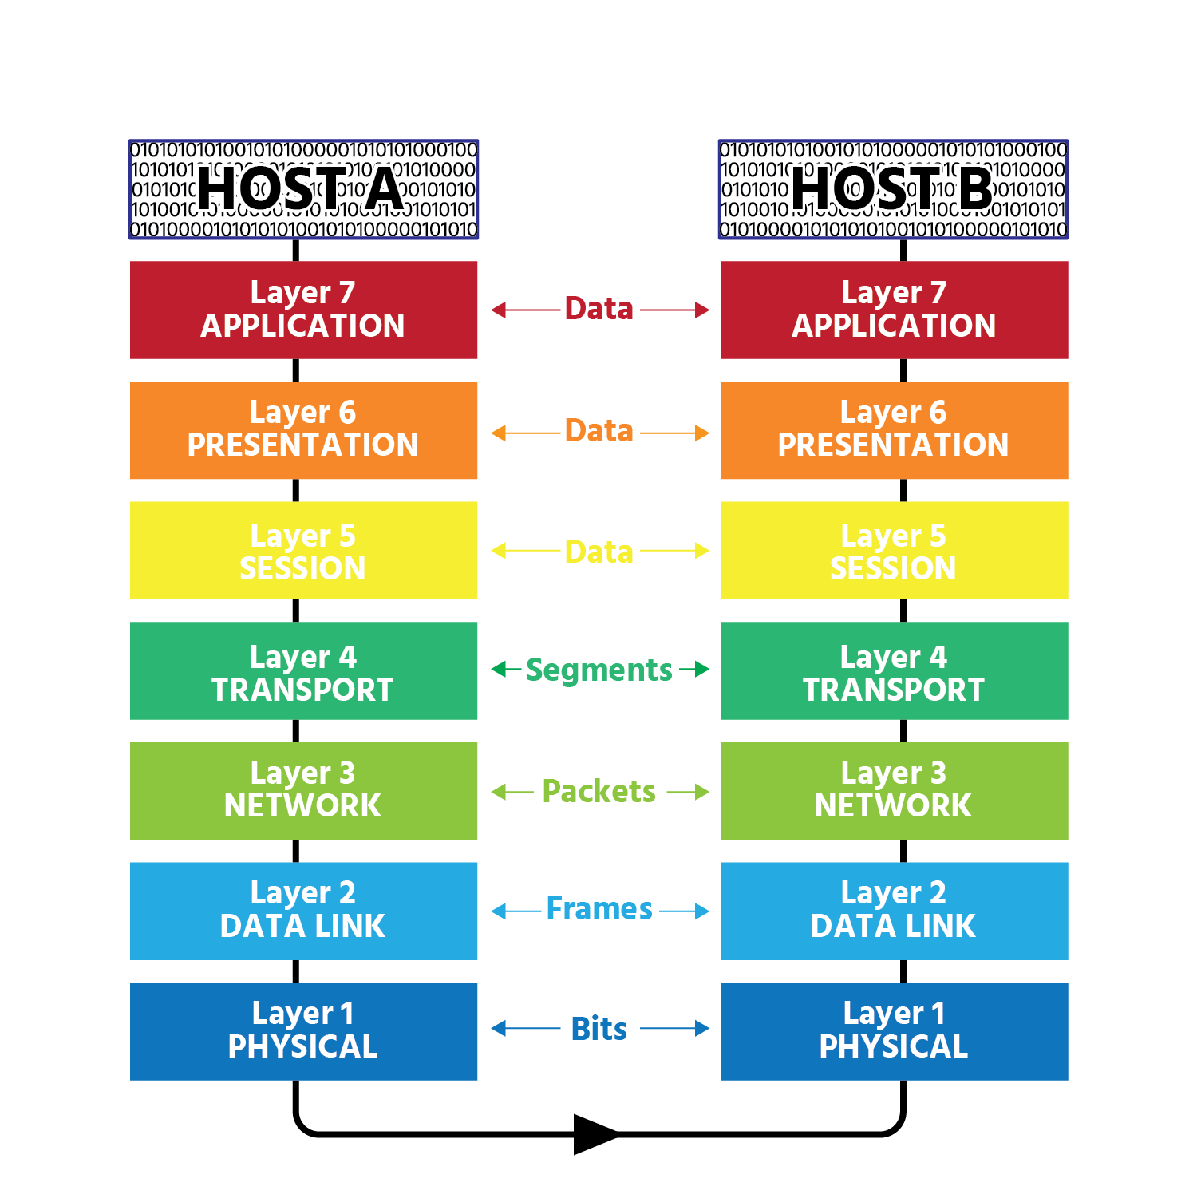

In Layers 7, 6, and 5, data is referred to simply as **data**.

In Layer 4 (the **transport layer**) data is divided into smaller chunks. A process called **encapsulation** takes place in which information is added to the data as it moves from Layer to Layer. This information (the precise contents of which will vary from layer to Layer) is a called a **header**. In layer 4, once a header is added to the data, the data is referred to as a **segment**. Its header will contain port numbers for the applications that will use the data is Host B. Layer 4 then hands each segment down to Layer 3.

In Layer 3 (the **network layer**) data is transferred from one **Internet Protocol** (IP) address to another via a router. Each segment that's been handed down from Layer 4 will be encapsulated with source information (Host A's IP address), destination information (Host B's IP address), an identification number, another number that identifies how many pieces the information that's being sent (the **payload**) has been broken up into, and part of that information. Once the header is attached, the segment is referred to as a **packet**. Layer 3 hands the packet down to Layer 2.

Layer 2 (the **data link layer**) is responsible for error-free data transfer from one device to another. The packets are encapsulated with Host A and Host B's Media Access Control (MAC- i.e., hardware) addresses, as well as with **Logical Link Control** (LLC) which maintains the link between devices as they transmit data across the physical network connection. Each packet is also encapsulated with a **footer** (or trailer), containing error-detecting information. With its header and footer/trailer attached, the packet is referred to as a frame. Layer 2 hands the frame down to Layer 1.

Layer 1 is the **physical layer** that consists of physical cables and connections. It converts frames into binary bits in the form of voltage for physical cables and radio signals for wireless connections.

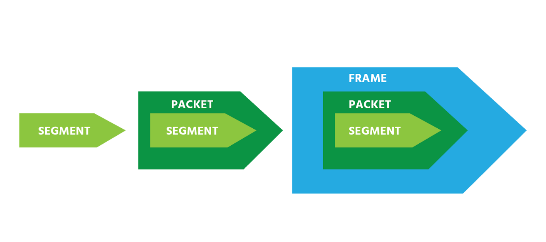

Host A's Layer 1 forwards these bits on to Host B's Layer 1, which hands them up to Host B's Layer 2. Host B's Layer 2 **de-encapsulates** the frame (removing its header and footer/trailer) before handing it up to Layer 3, where de-encapsulation again occurs. This process is repeated until the fully de-encapsulated data is delivered.

In the overlay networking used by network virtualization, endpoints connect the physical network (the underlay) to the overlay network. Encapsulated traffic is transferred between hosts via a stateless tunnel (i.e., no TCP connections are made with the tunnel) that is created between the source endpoint and the destination endpoint.

## Virtual Networking

As we've previously discussed, in virtual networking, some or all of the hardware components are replaced with virtual network components are replaced with virtual network components comprised of software. This eliminates the need to configure physical hardware components physically. Virtual network components can be configured more easily than physical components, allowing the networking of virtual machines to be managed with greater ease and flexibility.

Virtual machines must be connected to a virtual network component, and that virtual component must have access to the physical network. There are several ways the virtualized components can be connected to a physical network in order to allow VMs to communicate with each other and with other devices. This section explores the three main network types used to set up VMs with a connection in a Type 2 Hypervisor scenario (which is a hypervisor running on a host operating system). Think VMware Workstation and/or Fusion.

**Bridged Network**

A **bridged network** is a network type where both a virtual machine and the host that it is running on are connected to the same network. Bridged networking connects a VM to the network using the host computer's Ethernet adapter (also known as a network interface card or NIC. This is possible because the host shares its IP address with the VM.

With bridged networking, the virtual network adapter (vNIC) for the virtual machine connects to a physical NIC on the physical host system. The host network adapter enables the VM to connect to the Local Area Network (LAN) that the host system uses. Bridged networking works with both wired and wireless host network adapters.

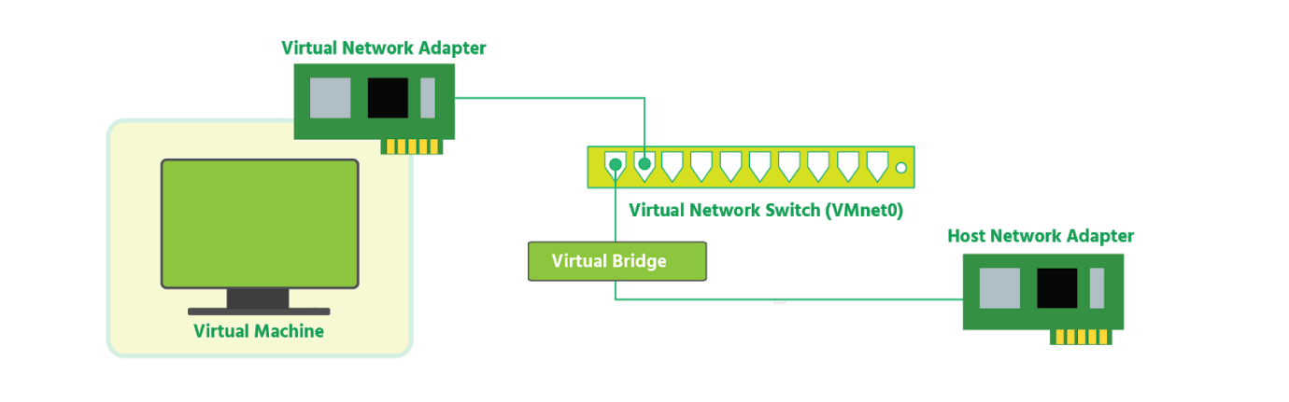

**Note**: The terms network interface card (NIC) and network adapter will be used interchangeably in this section.

Bridged networking treats the virtual machine as a unique identity on the network, separate from and unrelated to the host system. The VM is a full participant in the network. It has access to other machines on the network, and other machines on the network can contact is as if it were a physical computer on the network.

**NAT Network**

**Network Address Translation**(NAT) takes an IP address and translates it into another IP address. On a NAT network, a virtual machine does not have its own IP address on the external network. Instead, a separate private network is set up locally on the host computer.

NAT is useful when you have a limited supply of IP addresses. NAT works by translating addresses of virtual machines in a private network called a **VMnet** to that of the host machine. When a VM sends a request to access a network resource, **to the network resource it appears as if the request came from the host machine.**

The NAT device on the network translates the information going to the host's public IP address and forwards it to the private IP address for the VMs.

The VMnet is able to connect to the public external network using the translated IP addresses enabled by a feature called **port forwarding**. Port forwarding allows incoming web traffic to pass through a specific port, chosen by the administrator, to the internal network.

The NAT device is able to sort data packets intended for each virtual machine and sends them to the correct destination. When a packet does not reach its destination, this is called packet loss.

The topology (i.e., the physical and logical layout) of a NAT network generally involves a VM connected to a vNIC which allows it to connect to the virtual switch (vSwitch). The vSwitch is also connected to a NAT device that translates the IP addresses and allows port forwarding to connect to the external network.

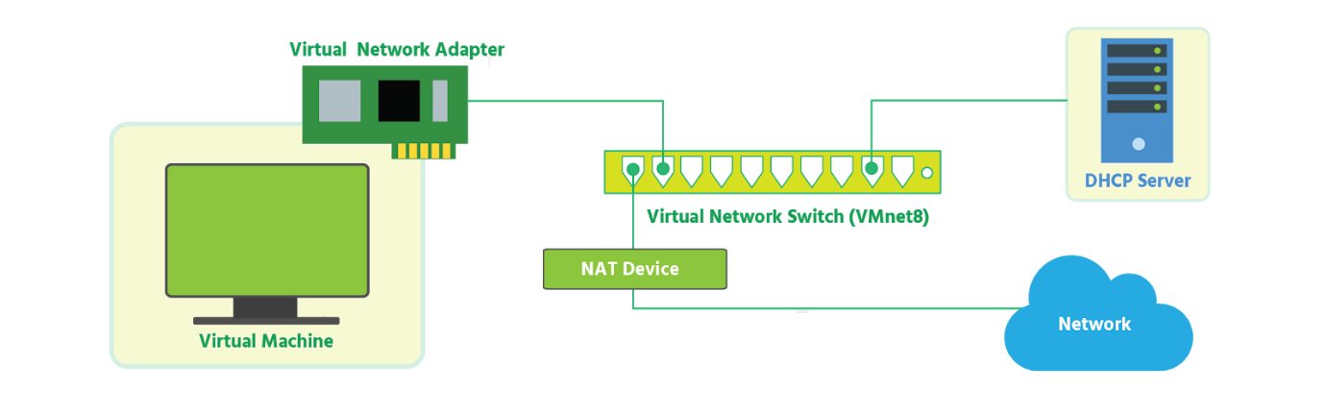

**Consider This**: In the default configuration, virtual machines get an address on this private network from the virtual DHCP server. DHCP is an acronym for **Dynamic Host Control Protocol**. A DHCP server is a system that uses the DHCP protocol to assign IP addresses to the devices on the network.

**Host-only Network**

**Host-only networking** creates a private internal network for the VMs to connect to, similar to a NAT network. However, **without IP address translation, the VMs can only stay in the private network and do not have direct access to the public external network.**

Host-only networking provides a network connection between the virtual machine and other VMs on the same host-only network, using a virtual Ethernet adapter (vNIC) that is visible to the host operating system. This approach can be useful if you need to set up an **isolated virtual network.**

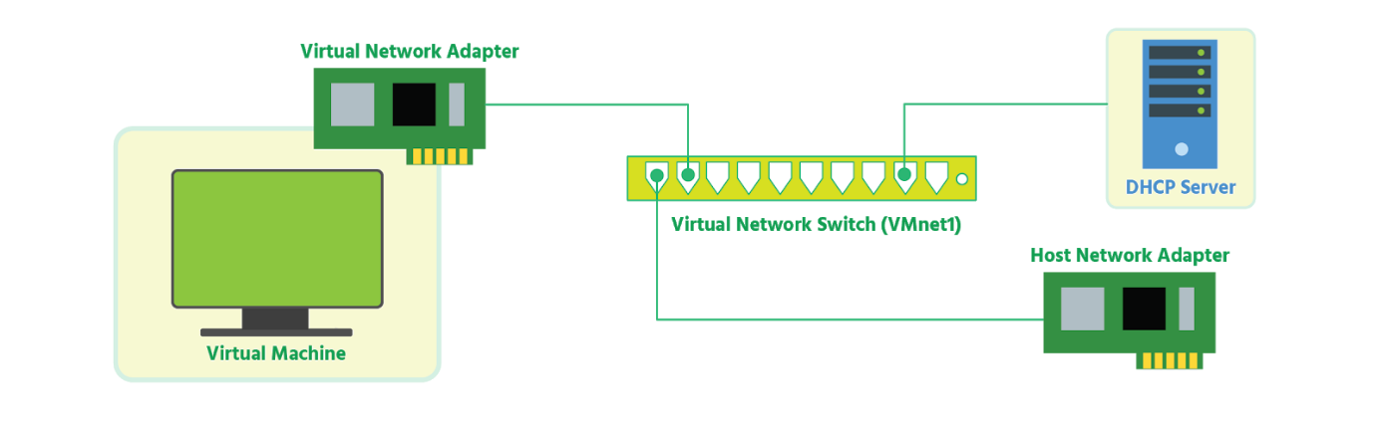

If you use host-only networking, your virtual machine and the host virtual adapter are connected to a private Ethernet network. Addresses on this type of network are also provided by a DHCP service.

## Virtual Switches

At the core of vSphere networking are virtual switches (vSwitches). They allow virtual machines to connect to each other and to connect to the outside world. By default, each ESXi host has a single virtual switch called vSwitch0.

The connection between a virtual machine and a virtual switch is similar to the connection between a computer's physical network adapter (NIC) and a physical switch. But instead of using a wired Ethernet cable, the virtual machine is connected to the port on the virtual switch by a virtual wire.

As with a physical switch, Layer 2 frames enter and exit a vSwitch. As with a physical switch, a vSwitch has ports organized into port groups. As with a physical switch, a vSwitch has uplink ports. These are physical network adapter ports found within the ESXi host, and connect the virtual switch within the ESXi host to a physical switch:

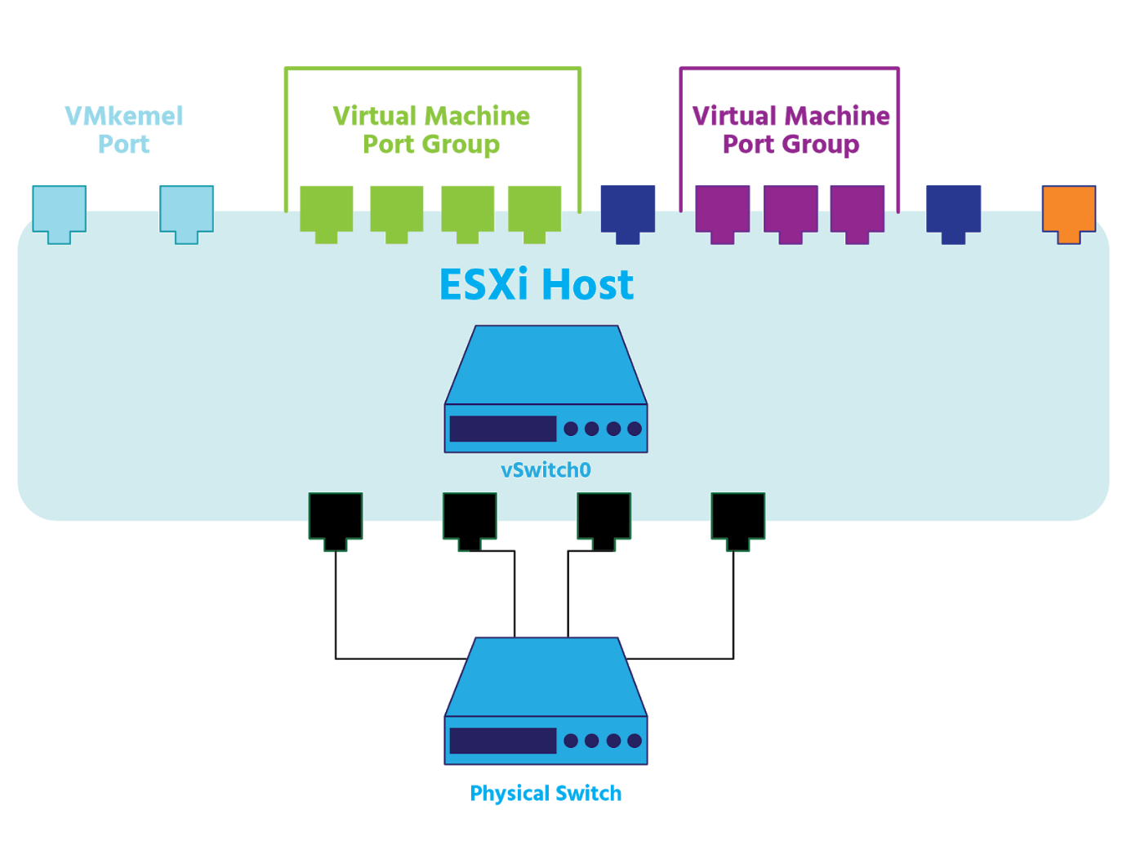

Uplinks connect the virtual switch to the physical world: they move physical 0s and 1s off the host and out into the world. A virtual switch can have one or more uplinks. Just as you can connect the uplink ports between the two physical switches in the virtual world, you can connect or uplink a virtual switch to a physical switch.

vSwitches allow you to make adjustments to your Virtual Local Area Networks (VLANs), to some of your security settings, to your load balancing, and to your Maximum Transmission Units (MTUs), which relate to the size of data frames, as well as to other settings which are beyond the scope of this course.

Standard Switches

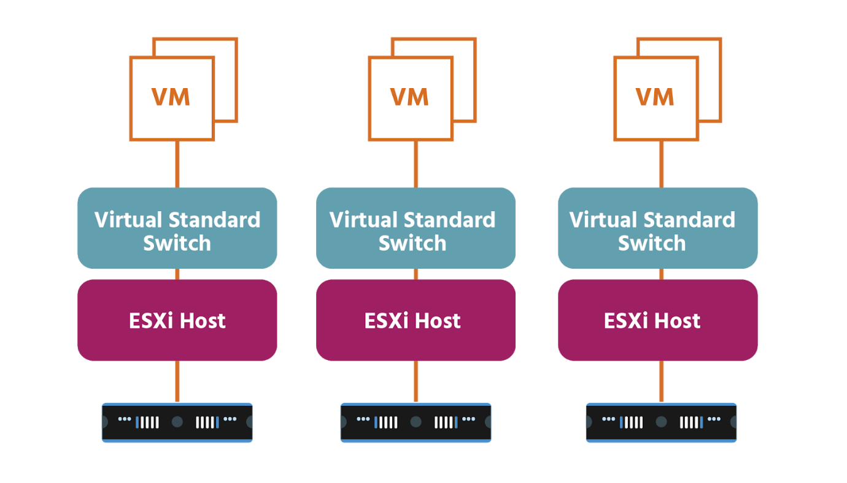

vSphere supports two types of virtual switches: the **standard virtual switch** (the vSwitch or *VSS*) and the **distributed virtual switch** (or *VDS*).

A standard switch works much like a physical Ethernet switch. It detects which virtual machines are logically connected to each of its virtual ports and uses that information to forward traffic to the correct virtual machines. A standard switch can forward traffic internally between VMs within the same ESXi host,

between VMs on different ESXi hos ts, and between VMs and physical machines, and can link to external networks.

A vSphere standard switch consists of port groups, VMkernel adapters, and uplink ports. To provide network connectivity to hosts and virtual machines, you connect the physical NICs of the hosts to uplink ports on the standard switch. Virtual machines have network adapters (or vNICs) that you connect to port groups on the standard switch. Every port group can use one or more physical NICs to handle its network traffic. If a port group does not have a physical NIC connected to it, VMs on the same port group can only communicate with each other and not with the external network.

To ensure efficient use of host resources on ESXi hosts, the number of ports of standard switches are dynamically scaled up and down. A standard switch on such a host can expand up to the maximum number of ports supported on the host.

A VMkernel adapter is a port that is used by the hypervisor to attach a service to the network. Every VMkernel adapter has an IP address by which this service is accessible. The uses of this VMkernel adapter include:

* VMware vMotion (which enables you to move VMs from one host to another while they're powered on with no downtime.
* Management port (which is used for ESXi management traffic and in most cases-except vSAN implementations- HA (or high availability) traffic)
* IP storage (which is any form of storage that uses TCP/IP network communication as its foundation)
* vSphere replication
* vSAN data replication

vSphere standard switches are created and configured on a per-host basis. So, if you have three hosts, you’ll need three virtual networks, three virtual switches, and three supporting port groups. Each host can have up to 4096 ports across both standard and distributed switches; a maximum of 1016 of these ports can be active at one time. Each standard switch can have up to 512 port groups.

Each logical port on the standard switch is a member of a single port group. Each port group on a standard switch is identified by a network label, which must be unique amongst other port groups on a host but consistent across hosts in order to ensure network connectivity.

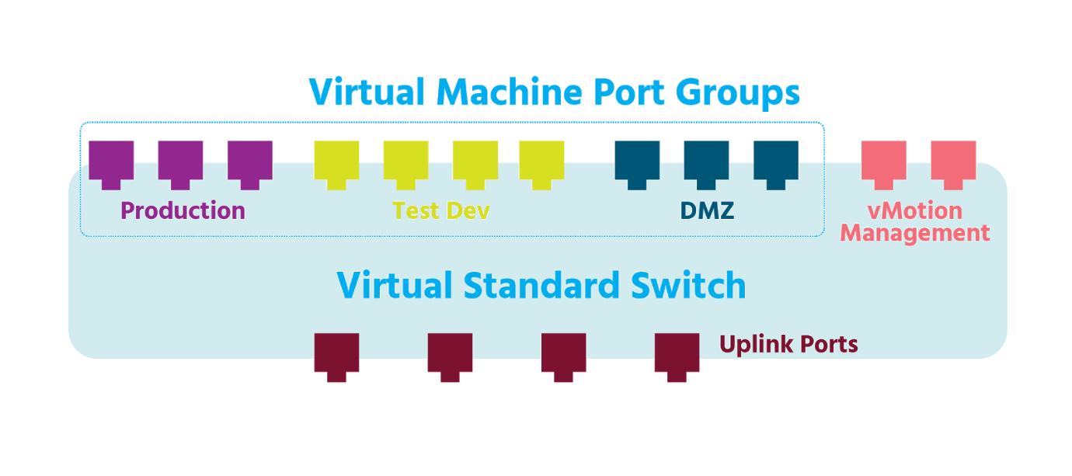

Although by default vSwitch policies (security policies, for example) are automatically assigned to the vSwitch's port groups, port group policies can be configured manually.

vSphere network switches can be divided into two logical sections. The *data plane* carries out tasks such as packet switching, filtering (where a switch discards a frame that has the same source and destination MAC addresses), and tagging (where frames are tagged to indicate which VLAN they belong to). The *management plane* is where an administrator configures the functions of the data plane. Each vSphere standard switch contains both data and management planes, and the administrator configures and maintains each switch individually

vSphere standard switches are supported by NSX-V, but not by NSX-T. Instead, VMware has developed a new virtual switch for the changing demands of modern networking. The switch is called an N-VDS, and we will look at it in the next section.

Distributed Switches

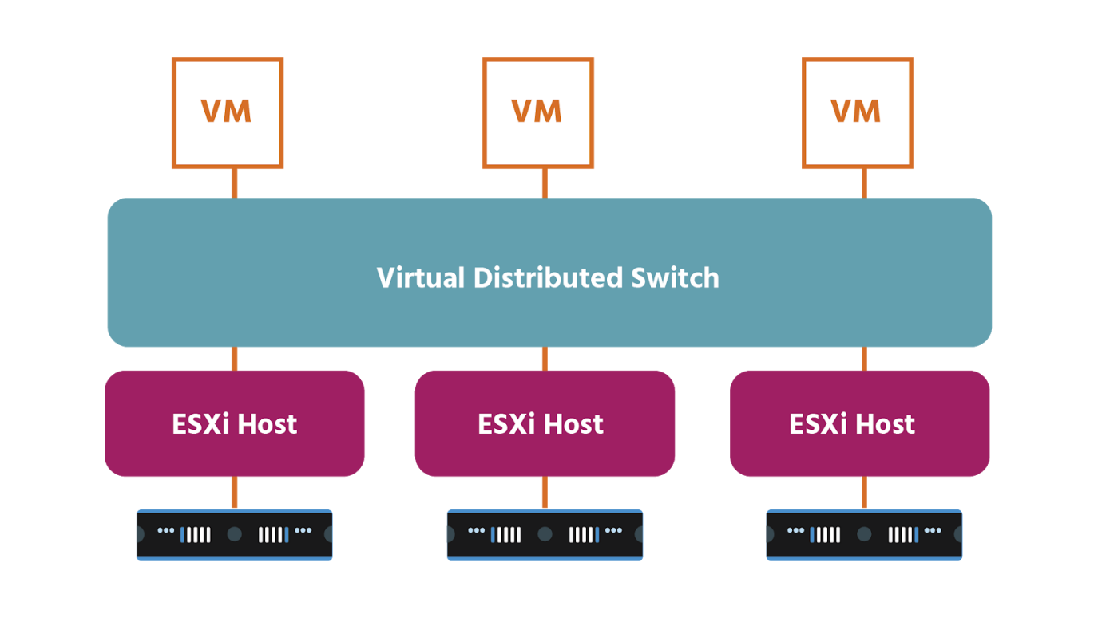

A **vSphere Distributed Switch** (or *vDS*) acts as a single switch across all associated hosts in a data center and provides centralized provisioning, administration, and monitoring of virtual networks. You configure a vDS on the *vCenter Server Appliance* (*vCSA*),

and the same settings are then added to all ESXi hosts that are associated with the switch. This lets virtual machines maintain consistent network configuration as they move (or migrate) from one host to another. Each vCenter Server system can support up to 128 vDSs, and each vDS can manage up to 2000 hosts. Each vDS can also support up to 10,000 port groups.

A vDS uses the physical NIC's of the ESXi host on which the VMs are running to connect them to the external network.

With a vDS, policies can be set for each individual port, not just for whole port groups. You can also block all ports in a distributed port group (though this might disrupt the normal network operations of the hosts or virtual machines using the ports).

Whereas a standard switch contains both data and management planes, and an administrator configures and maintains each switch individually, a vDS eases this management burden by treating the network as a pooled resource. Individual vSwitches are abstracted into one large vDS spanning multiple hosts across the data center. The data plane remains local to each vDS, but the management plane (the vCenter Server in this case) is centralized, which streamlines and simplifies VM network configuration. The vDS also provides enhanced network monitoring and troubleshooting capabilities, including templates to enable backup and restore for virtual networking configuration.

The data plane section of the vDS is called a ***host proxy switch***. The networking configuration that you create on a vCenter Server Appliance (the management plane) is automatically pushed down to all proxy switches (the data plane). Proxy switches support:

* network traffic between virtual machines on any hosts that are members of the distributed virtual switch
* network traffic between a virtual machine that uses a distributed virtual switch and a virtual machine that uses a VMware standard virtual switch
* network traffic between a virtual machine and a remote system on a physical network connected to the ESXi host.

NSX-V requires the use of vDS. NSX licensing entitles customers to the vDS. NSX-T comes with its own vDS type: the **N-VDS**, or **NSX Managed Virtual Distributed Switch**. As we’ll see later in the course, NSX-T can be deployed without a vCenter server. This means that an N-VDS switch is similarly not dependent on vCenter (as a vDS is) and can be used in a variety of cloud environments. It can provide network services to VMs running on both ESXi hypervisors and KVM hypervisors (which are built into Linux kernels).

On an ESXi hypervisor, *N-DVS* is implemented via the *NSX-vSwitch module* that is loaded into the hypervisor’s kernel. On a KVM hypervisor, N-DVS is implemented by the *Open-vSwitch* (*OVS*) module for the Linux kernel.

The primary purpose of an N-VDS is to forward the traffic that runs on transport nodes. Transport nodes are hypervisor hosts and NSX Edges that will participate in an NSX-T overlay. When you add a transport node to a transport zone (which defines the span of an NSX-V or NSX-T virtual network), the N-VDS associated with the transport zone is installed on the transport node. Each transport zone supports a single N-VDS which must have the same name as the transport zone. There are two types of transport zone: an **overlay transport zone** and a **VLAN transport zone.**

Remember that an N-VDS:

* can only attach to a single overlay transport zone
* can only attach to a single VLAN transport zone
* can attach to both an overlay transport zone and a VLAN transport zone at the same time; in that case, both transport zones and the N-VDS will have the same name.

Multiple N-VDSs and vDSs can coexist on a transport node; however, a physical NIC can only be associated with a single N-VDS or vDS.

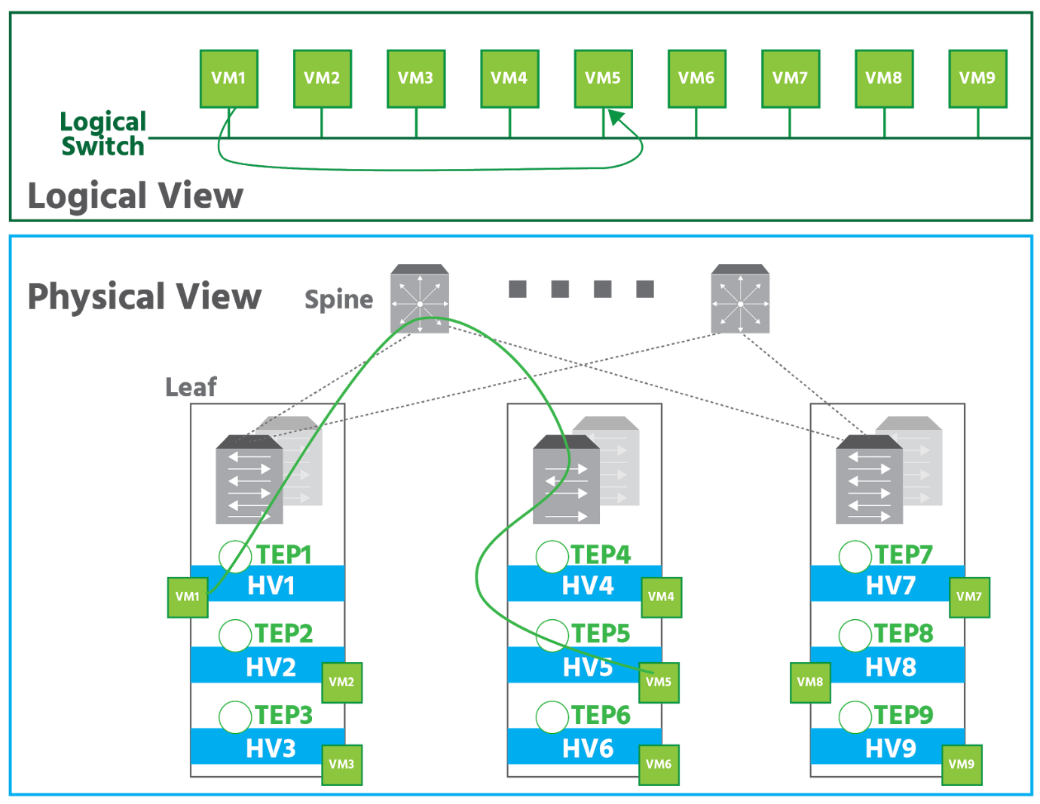

In the upper part of the diagram above, the logical view consists of eight virtual machines that are attached to the same logical switch, forming a virtual broadcast domain. The physical representation, at the bottom, shows that the five virtual machines are running on hypervisors spread across three racks in a data center. Each hypervisor is an NSX-T transport node equipped with a **tunnel endpoint** (TEP). The TEPs are configured with IP addresses, and the physical network infrastructure provides IP connectivity between them. An *NSX Controller* (which we’ll discuss later in the course) distributes the IP addresses of the TEPs so they can set up tunnels with their peers. The example shows *VM1* sending a frame to *VM5*. In the physical representation, this frame is transported via a tunnel between transport node *HV1* to transport node *HV5*.

The GENEVE overlay encapsulation protocol used by NSX-T provides better throughput (i.e., data transfer in a set amount of time) and uses fewer CPU resources.

NSX Logical Switching

As mentioned in section 2.1, logical switching in NSX-V is based on the VXLAN protocol while NSX-T is based on the GENEVE protocol. A logical switch is mapped to a unique VXLAN or GENEVE, which encapsulates the virtual machine traffic and carries it over the physical IP network. The NSX logical switch creates logical **broadcast domains** (devices connected to the same switch) or *segments* to which an application or virtual machine can be logically wired. This allows for flexibility and speed of deployment while still providing all the characteristics of a physical network's broadcast domains (VLANs).

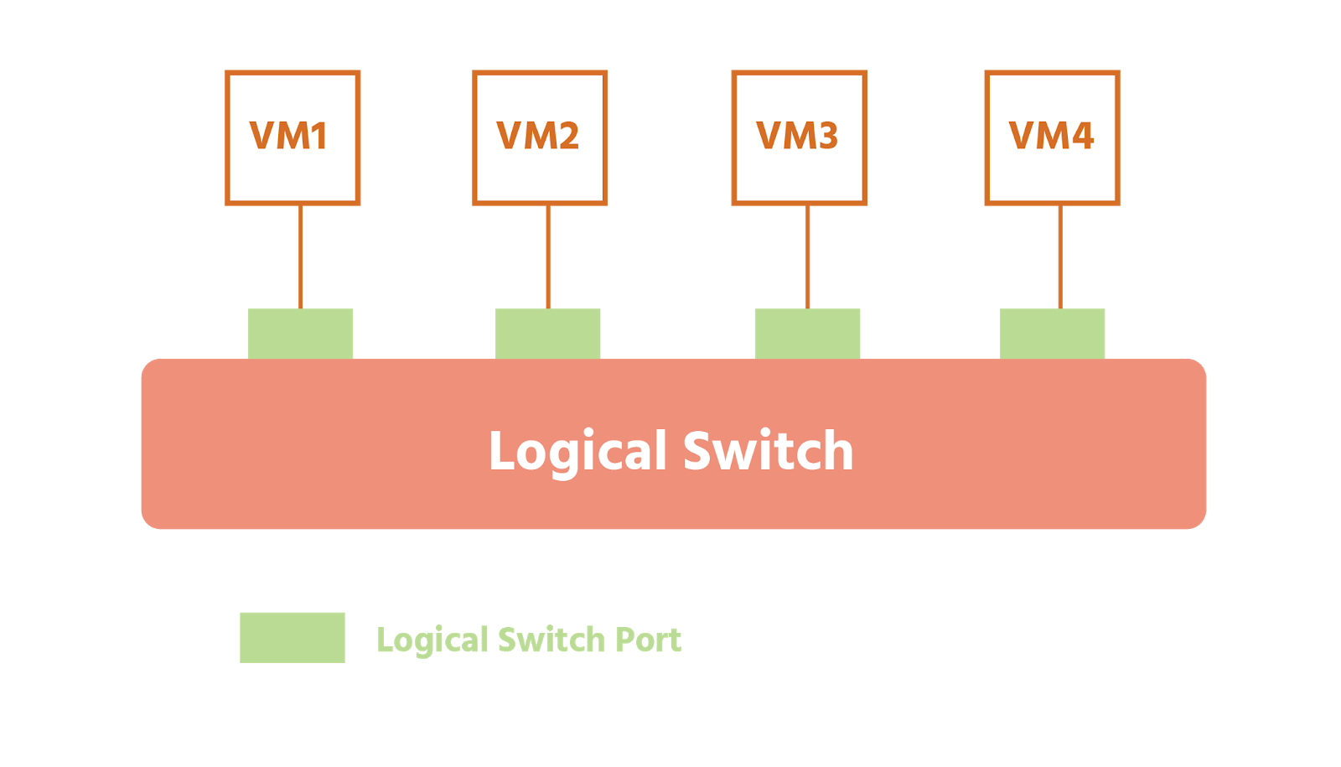

Both VXLAN and GENEVE protocols help you move to a software-defined data center model. It allows an administrator to provision a virtual machine that can communicate with another virtual machine on a different network without having to configure the physical switches and routers.

You may remember from section . 2.4 that VXLAN has several advantages over VLAN:

* VLAN networks can't be saved, snapshotted, cloned, deleted, or moved, which could negatively impact business continuity in the event of a system failure;
* every time a VLAN is extended, a time-consuming physical configuration is needed; by contrast, because VXLAN uses overlay technology, with virtual Layer 2 network is abstracted from the underlying physical network and can be configured and reconfigured very quickly.

What’s more, you can use VXLAN logical switches (which are Layer 2 Ethernet broadcast domains) to `cross Layer 3 network boundaries. This allows for virtual machine mobility within the data center (with vMotion) without limitations of the physical Layer 2 (VLAN) boundary.

As discussed in section 2.4, the original Ethernet frame generated by a workload is encapsulated with external VXLAN, UDP, IP and Ethernet headers to ensure it can be transported across the network infrastructure interconnecting the ESXi hosts.

Each logical switch is assigned a unique VXLAN numerical identifier. Each logical switch is created as a port group on the distributed switch. Logical switches can extend across multiple distributed switches.

VXLAN runs over standard switching hardware and has been embraced by more vendors.

The logical switching capability in the NSX-T platform provides the ability to create isolated logical L2 networks with the same flexibility and agility that exists for virtual machines.

## NSX Logical Routing

Today we have routing that is built directly into the host’s hypervisor. With NSX logical routing, we can now connect both virtual and physical endpoints that are located in different logical Layer 2 networks. This is made possible by the separation of physical network infrastructure from logical networks that network virtualization provides.

Network edge security and gateway services (such as DHCP, NAT, Virtual Private Networks - VPN - and load balancing) are provided in NSX-V by what’s known as an NSX Edge. An **NSX Edge** can be installed as a distributed logical router (DLR), which is a virtual router that can use both the fixed, manually configured network routes of static routing and dynamic routing, where routers communicate with each other updating routes in real-time. An NSX Edge can also be installed as an Edge Services Gateway or ESG (more about ESG will be discussed in the next section).

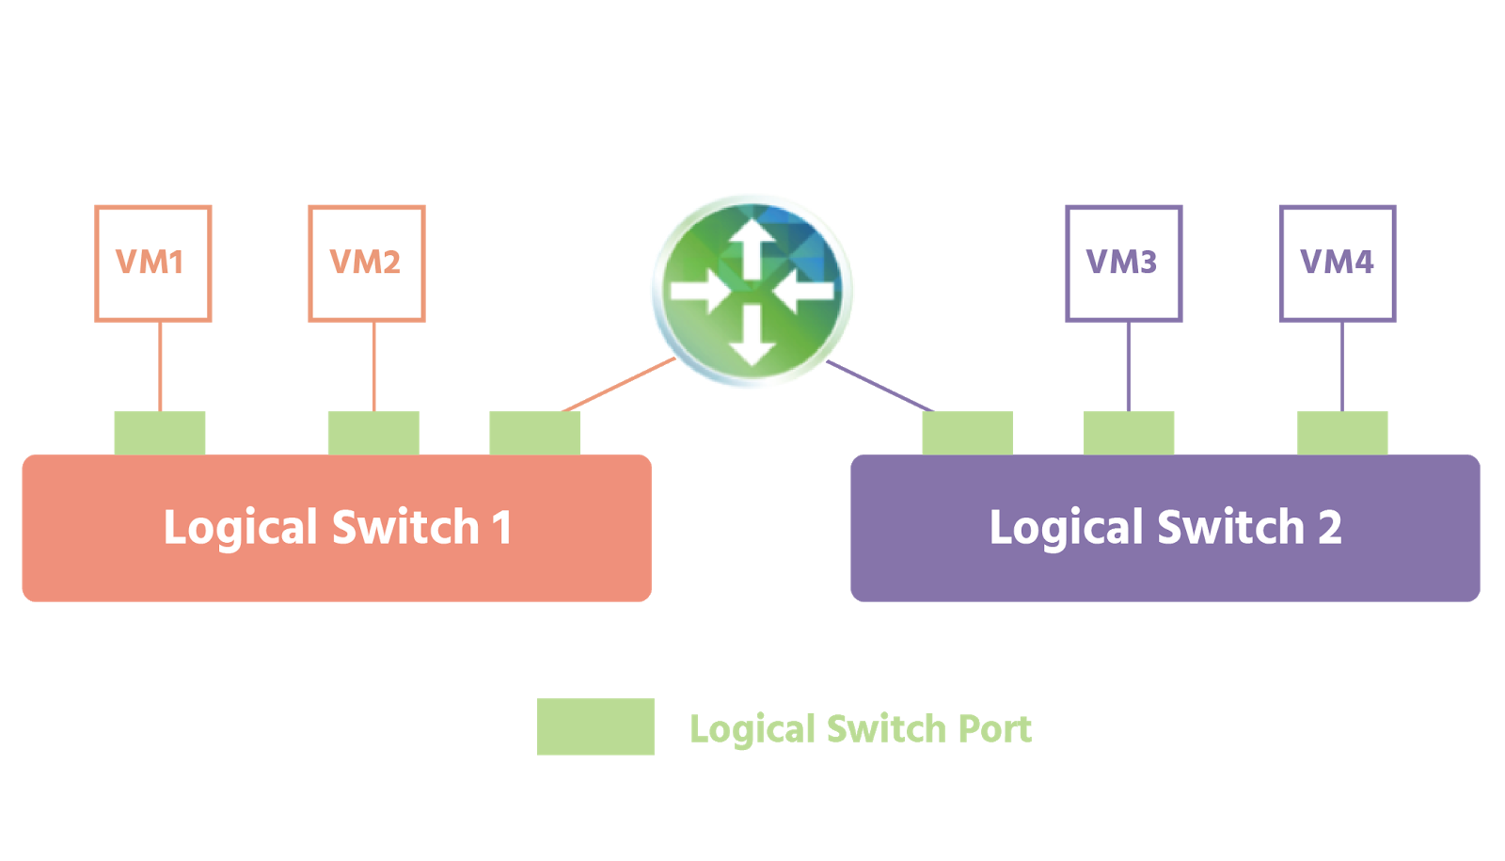

NSX-V’s DLR provides **East-West** distributed routing. (East-West refers to traffic within the same data center while in the same NSX environment.) This means that two VMs can be on the same host but on different subnets, and still communicate without their traffic having to leave the hypervisor.

By providing the gateway services mentioned above, NSX-V's ESG connects isolated networks to shared uplinks.

NSX-T introduces a two-tiered routing architecture that enables the management of networks at the provider tier (**tier-0**) and user tier (**tier-1**). The tier-0 logical router is attached to the physical network for **North-South traffic** (that is, traffic coming into the data center from the outside world); it handles traffic between the logical and physical networks. The tier-1 router can connect to the tier-0 router via uplinks, that can connect to logical switches and manage east-west communications.

It’s not necessary to use both tiers. A tier-0 logical router can be connected by itself to the physical infrastructure for traffic heading outwards exiting the perimeter network (**northbound traffic**) and then connect directly to logical switches in the NSX environment for traffic coming into the data center (**southbound traffic**).

Tier-0 and tier-1 logical routers are both created on transport nodes.

NSX-T supports static routing and the dynamic routing protocol eBGP on tier-0 logical routers. (eBGP stands for **External Border Gateway Protocol**, and it helps connect the networks of different organizations.) Tier-1 logical routers support static routes but do not support any dynamic routing protocols.

If NSX-T requires services such as NAT or an edge firewall (see section 4.7.1), these can be enabled on Edge nodes. To improve availability, edge nodes can be combined into a cluster.

## Edge Routing and NAT

In a network, the edge is typically the point where every customer and device connection come into and depart from a data center. Specialized **edge routers** are used here. These are designed to be able to deal with the many types of data packets (and the different routing protocols) coming in and out of the data center. High availability (a high percentage of uptime) and redundancy (duplicate devices kept in case of system failure) are crucial. And as a data center’s initial contact-point with the outside world, edge routers have a key role to play in a network’s security.

**NSX-V Edge Services Gateway** (ESG) is a multi-function, multi-use virtual machine appliance for network virtualization. It gives you access to the logical services that we’ll be looking at in the coming sections. Multiple ESG virtual appliances can be installed in a data center. NSX-T provides the same services through an **NSX Edge** appliance - not to be confused with an Edge Services Gateway!

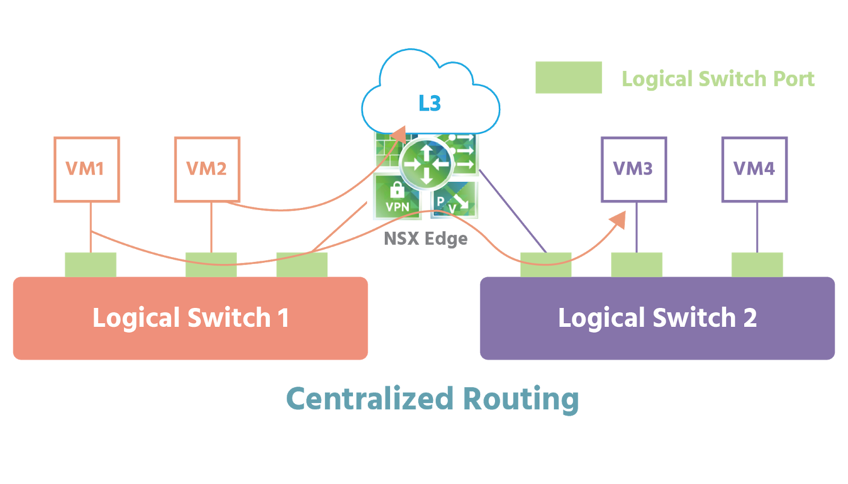

**ECMP** (equal cost multi-path) can be used to increase bandwidth between physical and virtual networks. (Bandwidth is the amount of data that can be sent from one point to another in a set amount of time.) ECMP also provides faster convergence (the merging of data, telephone, and video networks into a single network).

If centralized services (such as NAT) need to run on the Edge appliance, the appliance will need to be in what’s known as active-standby mode. In this mode, all stateful services (i.e., services that keep track of the network’s state - load balancing, for example) are available.



Dynamic routing uses protocols such as **Open Shortest Path First** (OSPF – an intra-domain protocol that prioritizes the shortest path based on the cost of available paths) in the case of NSX-V, and **Border Gateway Protocol** (BGP – an inter-domain protocol that prioritizes the best path as defined by a list of attributes) in the case of NSX-T Data Center.

As discussed in section 4.1, Network Address Translation (NAT), takes an IP address and translates it into another IP address. ESG supports both source NAT where a private IP address is translated into a public IP address, and destination NAT, a public IP address to private IP address translation. NAT is also an integral part of load balancing, which we’ll discuss next.

Load Balancing

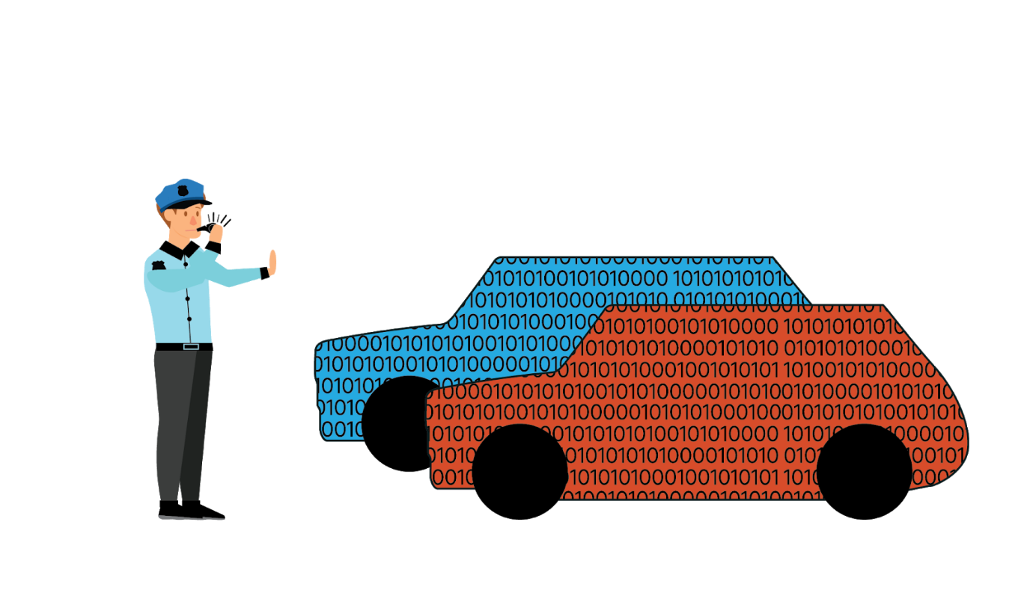

A **load balancer** evens out workloads to prevent servers from being overwhelmed. Its other main use is to provide high availability. Imagine, for example, a service being available on several hosts but all traffic being sent to just one node. In this situation, a load balancer will redirect ALL traffic - just in case there’s a failure.

Rather like traffic police directing traffic to keep it flowing and free from congestion, it distributes incoming network and application traffic across multiple servers (together known as a **server pool**). It only routes traffic to servers that are able to fulfill the client request and do so in a way that prevents any single server being over-burdened while maximizing overall network speed and use of resources. How does it know that a server is able to handle requests? By carrying out **health checks** in which it periodically attempts to connect with the server. If a response is received, the load balancer knows that the server is available. If a server fails to respond (i.e., is offline), the load balancer diverts traffic to the servers that are still online. When a new server is added to the **server pool**, the load balancer immediately starts sending traffic its way.

The NSX load balancing service is specially designed for IT automation and uses the same central point of management and monitoring as other NSX network services. It’s rich with features and functionalities. Here are just a few:

* the Edge VM active-standby mode provides high availability for the load balancer
* support for any TCP (Transmission Control Protocol) application
* support for UDP (User Datagram Protocol) applications
* health checks for multiple connection types (TCP, HTTP, HTTPS), including content inspection
* the NSX platform can also integrate load-balancing services offered by 3rd party vendors
* NSX Edge offers support for two deployment models: **proxy mode** (a.k.a. one-arm mode), and **inline mode** (a.k.a. transparent mode).

In *proxy mode*, an *NSX Edge* is connected directly to the logical network where load-balancing services are required. The external client sends traffic to the **Virtual IP Address** (*VIP*) provided by the load balancer. (VIPs are multiple virtual IP addresses assigned to servers that share a regular IP address based on a single NIC.) The load balancer performs two address translations on the original packets received from the client: **destination NAT** (*DNAT*) to replace the VIP with the IP address of one of the servers in the server pool, and **source NAT** (*SNAT*) to replace the client IP address with the IP address identifying the load balancer itself. *SNAT* forces through the load balancer traffic on its way back from the server pool to the client. The server in the server pool replies by sending the traffic to the load balancer. The load balancer again performs a source and destination NAT service to send traffic to the external client, using its VIP as the source IP address.

Proxy mode is simpler to deploy and provides greater flexibility than traditional load balancers. It allows the deployment of load balancer services (e.g., *NSX Edge* appliances) directly on the logical segments without requiring any modification on the centralized *NSX Edge* that is providing routing communication to the physical network.

One limitation of proxy mode is that it requires provisioning more *NSX Edges* and requires the deployment of source NAT, which means that the servers in the data center do not have the original client IP address. The load balancer can insert the original IP address of the client into the HTTP header before SNAT is performed – a function named **Insert X-Forwarded-For HTTP** header. The servers, therefore, have the client IP address. This is, however, limited to HTTP traffic.

With *inline mode*, the *NSX Edge* is inline to the traffic destined for the server pool. The external client sends traffic to the VIP provided by the load balancer. The load balancer – a centralized *NSX Edge* – performs only destination NAT (DNAT) to replace the VIP with the IP address of one of the servers deployed in the server pool. The server in the server pool replies to the original client IP address. The traffic is received again by the load balancer since it is deployed inline, typically as the default gateway for the server pool. The load balancer performs source NAT to send traffic to the external client, using its VIP as the source IP address.

Inline mode is also quite simple, and additionally, the servers have the original client IP address.

L2/L3 VPN

A **Virtual Private Network** (or *VPN*) helps extend a private network over a public network privately, as the name suggests, and securely. It does this by creating a tunnel or private line from a local network to an external network (and vice versa) for the secure transmission of data. It encrypts the data before it leaves a device, and then masks the sender/recipient’s IP (Internet Protocol) address by connecting to the server of a VPN service provider. The VPN service provider assigns the sender/recipient a temporary IP address that cannot be traced back to them.

The *tunnel* is a virtual connection established between two endpoints using a tunneling protocol. Tunneling protocols enable the secure transmission of every type of data between two points on a network or from one network to another. Two of the most widely-used tunneling protocols are:

* **Internet Protocol Security** (*IPsec*), which authenticates senders, checks the integrity of data being transmitted and encrypts it; users need to install software on their machines in order to be able to establish a connection
* **Secure Sockets Layer** (*SSL*), or its successor **Transport Layer Security** (*TLS*), both of which enable secure communication across public networks from a web browser.

The VPN service provider’s server decrypts the data and sends it to its destination.

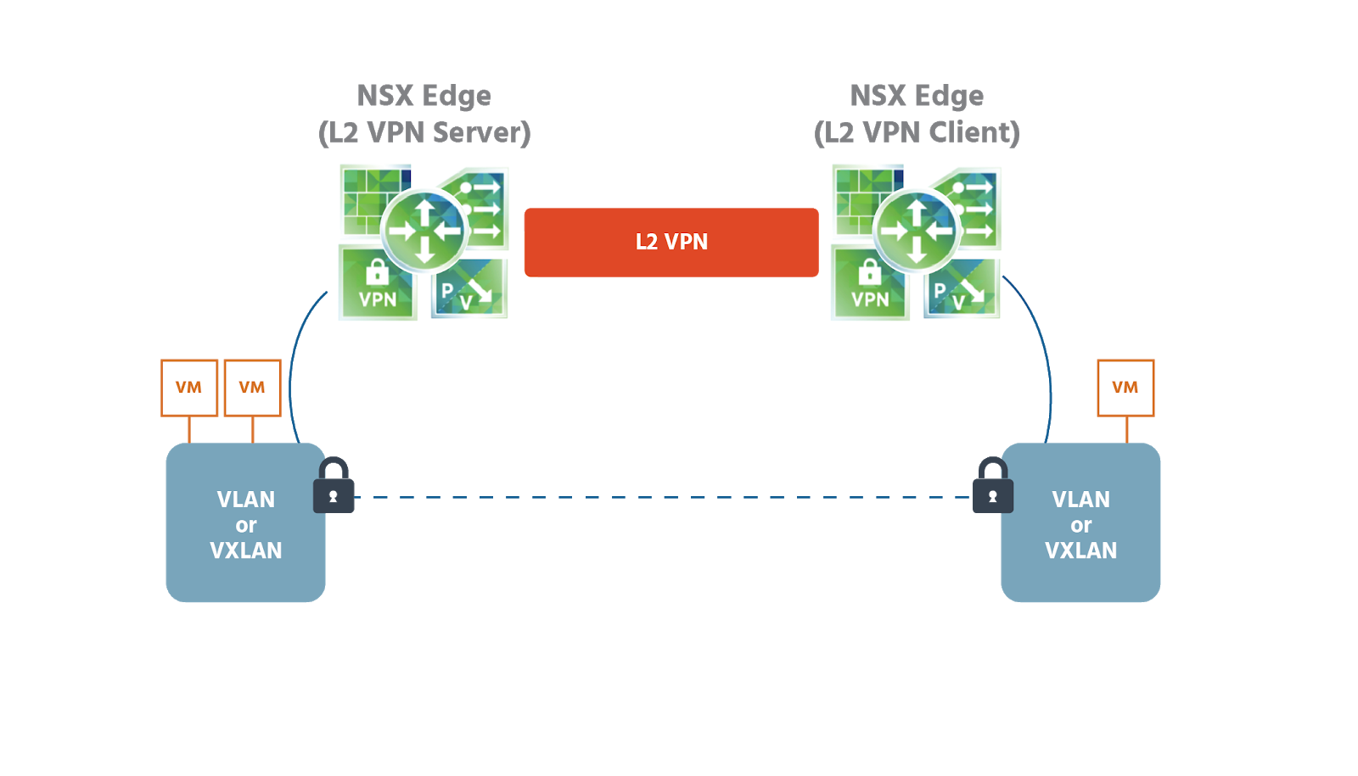

With **Layer 2 VPN** (*L2 VPN*), you can extend Layer 2 networks (*VLANs* or *VXLANs*) across multiple sites that are on the same broadcast domain. Data is forwarded to one of the Layer 2 formats (*Medium Access Control (MAC)* and *Logical Link Control (LLC)*, for example) on a service provider’s Layer 3 network running over the public internet infrastructure and is then converted back to Layer 2 format at the receiving end. VMs in Layer 2 can seamlessly communicate with each other over an *L2 VPN* even if they are located in different data centers. The extended network is a single subnet with a single broadcast domain, so VMs remain on the same subnet when they are moved between network sites, and their IP addresses remain the same.

A *L2 VPN* might be used for connections in the following scenarios:

* between an *NSX-T Data Center L2 VPN* server and an *L2 VPN* client hosted on an *NSX Edge* managed in an *NSX Data Center for vSphere*; a managed *L2 VPN* client is limited to supporting VXLANs
* between an *NSX-T Data Center L2 VPN* server and an *L2 VPN* client hosted on a standalone or unmanaged *NSX Edge*; an unmanaged *L2 VPN* client supports VLANs
* between an *NSX-T Data Center L2 VPN* server and *NSX-T Data Center L2 VPN* client; in this scenario, you can extend the L2 network between two software-defined data centers (SDDCs) deployed on the cloud, such as *VMware Cloud on Amazon*.

**Layer 3 VPN** (*L3 VPN*) services are used to provide secure Layer 3 connectivity into the data center network from remote locations.

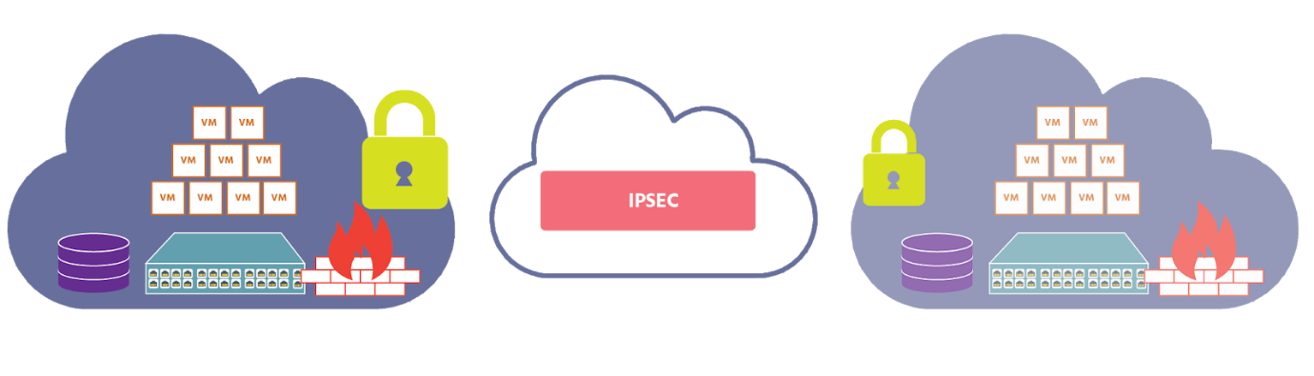

As shown in the illustration above, the *L3 VPN* services can be used by remote clients using SSL tunnels to securely connect to private networks behind an *NSX Edge* gateway which is acting as an *L3 VPN* server in the data center. This service is usually referred to as **SSL VPN-Plus**. (A *gateway* is a device that enables data to be transmitted from one network to another. Unlike switches and routers, they can use more than one protocol at the same time and can function at all seven layers of the OSI model.)

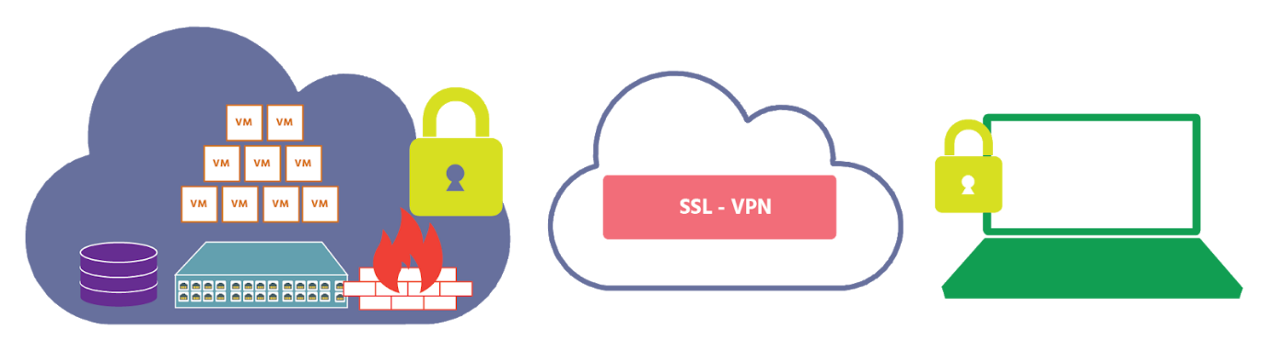

Alternatively, the *NSX Edge* can be deployed to use standard IPSec protocol settings to operate with all major physical VPN vendors’ equipment and establish site-so-site secure L3 connections. It is possible to connect multiple remote IP subnets (broadcast domains) to the internal network behind the *NSX Edge*. Connectivity, in this case, is routed since the remote and local subnets are part of different address spaces (broadcast domains).

NSX Logical Firewall

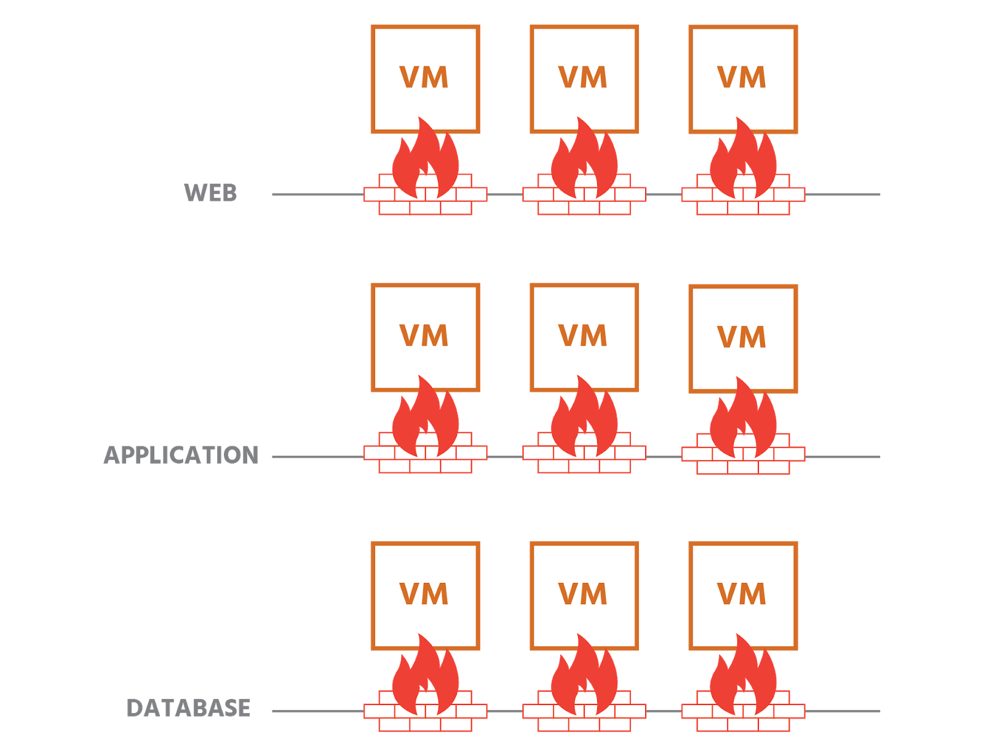

NSX logical firewalls provide security mechanisms for dynamic virtual data centers and consist of two components to address different uses. The centralized Edge firewall offered by **NSX Edge Services Gateway** (*ESG*) focuses on the north-south traffic enforcement at the data center perimeter. And the **Distributed Firewall** (*DFW*) is enabled in the kernel on the ESXi host and focuses on east-west traffic controls. Together, these two components address the firewall needs of virtual data centers.

These security technologies can be deployed independently or together. Ideally, they’ll be used together as part of a broader security strategy.

The NSX distributed firewall is a stateful firewall, meaning that it monitors the state of active connections and uses this information to determine which network packets to allow through the firewall. Data packets flowing through the network are identified by the following:

* source address
* source port
* destination address
* destination port
* protocol

A distributed firewall on an ESXi host (one instance per virtual machine vNIC) contains two tables: a rule table to store all policy rules, and a connection tracker table to temporarily store (or *cache*) traffic flow entries for rules with a permit action. DFW rules are enforced in a top-to-bottom order. Traffic that needs to go through a firewall is first matched against a firewall rules list. Each packet is checked against the top rule in the rule table before moving down the subsequent rules in the table. The first rule in the table that matches the traffic parameters is enforced. The last rule in the table is the DFW default policy rule: packets not matching any rule above the default rule will be enforced by the default rule.

## Edge Firewall

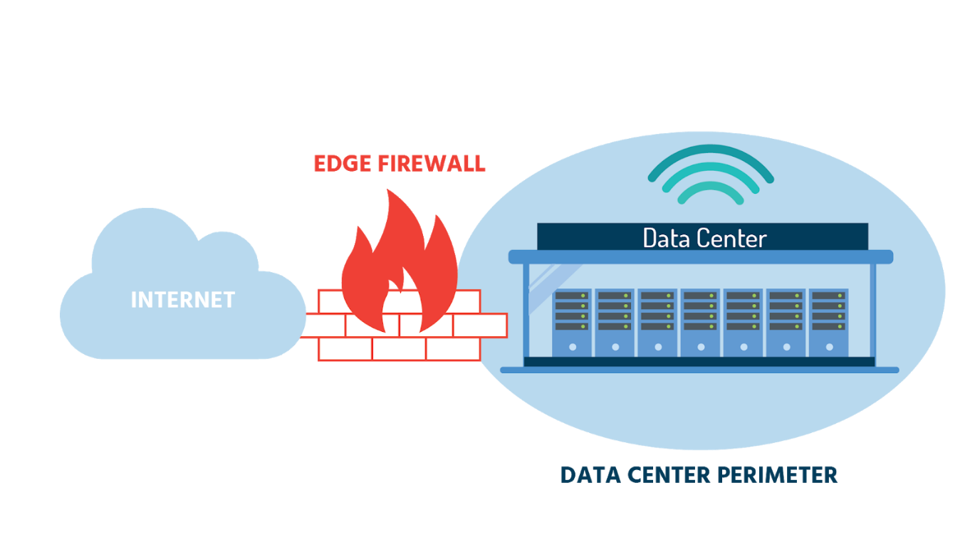

An edge/perimeter firewall is a network security system, either hardware or software-based, that controls incoming and outgoing traffic based on a set of predetermined security rules. The **NSX Edge firewall** provides stateful perimeter defense for north-south traffic flows between the virtual and physical networks. It’s used on the logical router and provides network address translation (NAT) as well as site-to-site IPsec and SSL VPN functionality. The NSX Edge firewall is available for virtual machines and has a high availability mode.

The Edge firewall can be managed with the same management tools as for the distributed firewall. ESG also provides a **multiple management model** whereby, for example, individual teams within an organization can configure their own firewalls without needing access to the entire network.

# **Module 5: The NSX Data Centre**

## The NSX Data Center

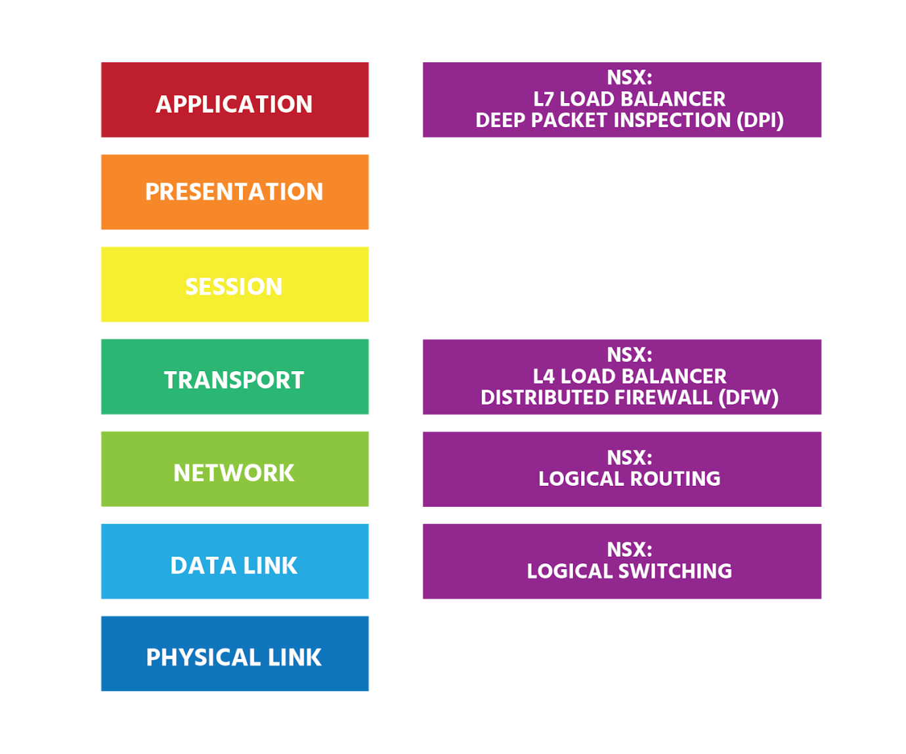

In Information Technology (IT), the quest is always to do more with less, and for that you need a network that’s secure enough to fortify you from threats, fast enough to meet your business needs, and agile enough to instantly accommodate your demands - while spending less time and money to get it all done.

The NSX Data Center – as part of a software-defined data center (SDDC) - achieves this. It's a totally new approach. It reproduces the whole network, whether the network is simple or complex, in software. Provisioning and managing networking functions (from firewalling, to switching, to routing, to load balancing) in software instead of hardware results in level security, speed, agility, and cost-efficiency that simply isn't possible with the traditional architecture.

For even greater control of your SDDC, vRealize Network Insight gives you a 360° view across virtual, physical, and multi-cloud environments to help you quickly troubleshoot connectivity issues.

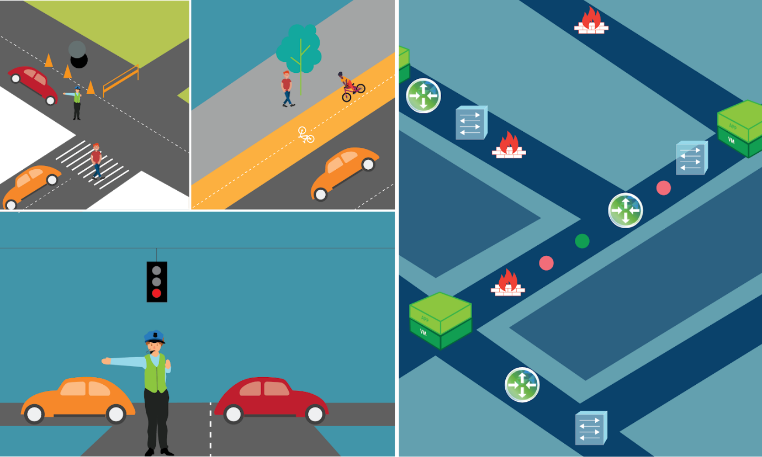

For example, if two virtual machines are unable to talk to each other, or there are bottlenecks between two VMs, issues can be quickly pinpointed for rapid resolution. This 360° view also provides you with insights into applications' dependencies (that's all the programs they depend on to function properly), while you're planning application migration to a public cloud, a different data center, or a disaster recovery site.

Different areas of your network require different rules for security. vRealize Network Insight allows you to plan security for applications across private, public, and hybrid clouds. It helps accelerate micro-segmentation deployment by providing recommendations for VMware NSX firewall rules. vRealize Network Insight gives you a view of your entire NSX infrastructure with a powerful topology map that alerts you to potential issues and even provides recommendations for fixes.

With so much control of your networking environment, all your teams will move faster and more safely.

NSX-V was first released in 2013 and met a real need in the market - within a few months three of America’s top five investment banks and several of the most respected enterprises around the world were using it. It went on to become the leading network virtualization platform and continues to serve the needs of its customers. However, times change. Not all applications run in VMs now. Containers and cloud-native apps are increasingly the norm. It was for this transformed environment that VMware developed NSX-T Data Center. (The “T” stands for “Transformers”.) It has some common features with NSX-V, as we’ve seen. Both provide software-based network virtualization using software-based overlay technologies. Both provide distributed routing and firewalling. And both provide automation to increase agility. But unlike NSX-V, NSX-T is not tightly-integrated with vCenter. It works in all types of environments to connect all types of applications. It can support multiple hypervisors (ESXi and KVM); connect with a VM, a container, or a bare metal server (i.e., a physical server used by just one customer), on-premises or in a private cloud, public cloud, or multi-cloud environment; and integrate seamlessly with Kubernetes, Docker, OpenStack, VMware Pivotal Container Service (PKS), Red Hat OpenShift, Pivotal Cloud Foundry, Amazon Web Service (AWS), and Microsoft Azure.

VMware will continue to develop NSX-T Data Center to meet the networking and security needs of the future.

## Bringing Network Virtualization to the SDDC

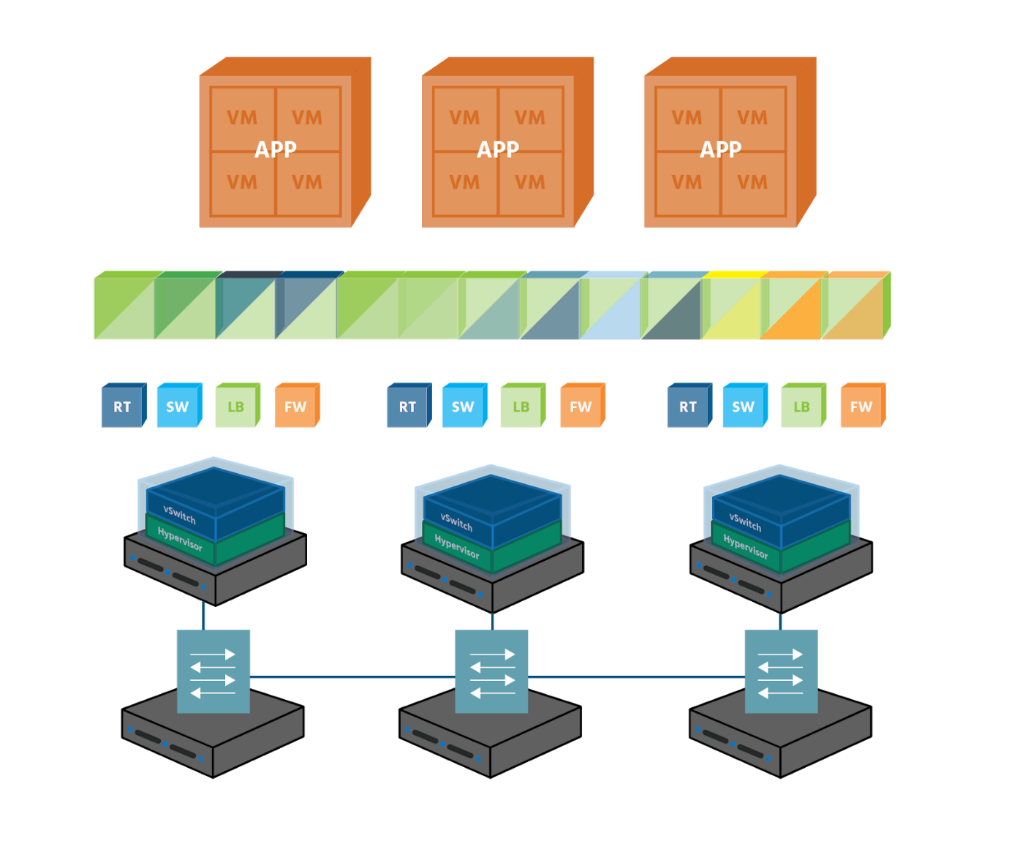

In a survey of its more than half-a-million customers, VMware found that 70% of respondents had virtualized over 75% of their IT infrastructure. However, only 12% had virtualized their networks, meaning that they weren’t yet benefiting from the increased operational, time, and cost efficiencies to be gained from a fully software-defined data center.

VMware NSX is the industry leader for network virtualization. By abstracting the traditionally physical infrastructure of routers, switches, load balancers, and firewalls into a data center's virtualization layer, the data center becomes agile and responsive to business needs as they change. Virtual networks can be created, copied, moved, deleted, and restored quickly and easily, with no physical reconfigurations necessary.

With micro-segmentation (which we'll discuss later on in this course) threats are prevented from moving laterally, server to server, inside the data center. You can also tie security policies directly to an application and ensure that even as the application changes over time, it will maintain its protection.

Automation brings immediate gains in efficiency and innovation while enabling IT to keep up with the speed of business. The NSX Data Center uses standardized, pre-defined templates, to provision consistent networking and security, speeding up provisioning time from days or weeks to seconds.

Multiple users can share the same physical environment and cloud environment using virtual networks invisible to each other. So, everyone is working more efficiently than ever. With NSX Data Center for Multi-cloud Networking, you can replicate the networking and security configuration of your environment across multiple clouds and physical sites, ensuring continuous availability of resources and services. You can also seamlessly connect applications deployed anywhere, and extend your on-site network to the public cloud, moving applications back and forth as your needs change.

Key Components

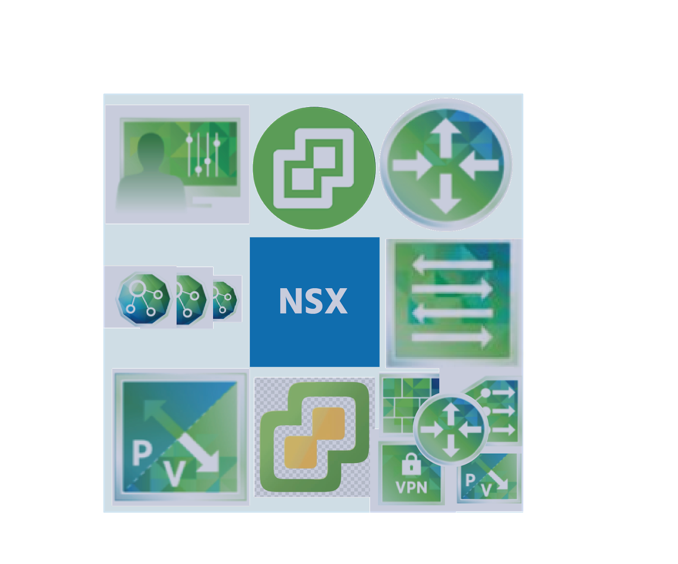

NSX-T provides networks that support any application on any compute platform in any infrastructure. NSX-T networks provide connectivity, security, and availability, all through one set of management tools and all in software.

With NSX-V, the *NSX Manager*centralizes the management of a network and is available in the *vSphere Client*. (vSphere virtualizes and aggregates - i.e., gathers together - the underlying physical hardware resources across multiple systems and provides pools of virtual resources to the data center.) The *NSX Manager* is based on the Photon operating system - a Linux distribution developed by VMware and optimized for cloud-native applications, cloud platforms, and VMware infrastructure. The *NSX-T Manager*, on the other hand, runs on the Ubuntu operating system - a Linux distribution developed by Canonical and used on desktops and in data centers all over the world.

Administrators usually tie network virtualization to their cloud management platform, and NSX can be integrated with any cloud management platform through *Representational State Transfer* (REST) APIs. A REST API is a software architectural style that allows NSX objects such as logical routers and switches to be created, retrieved, changed/updated, and deleted. NSX-V can be configured through vSphere Client, through a command-line interface (CLI), and through a REST API.

Some of NSX Data Center’s other key components include:

* *logical distributed* (i.e., spread out but connected) *switching* which allows you to reproduce the complete Layer 2 and Layer 3 functionality in a virtual environment, decoupled from the underlying physical hardware.
* *NSX Gateway*, a Layer 2 gateway that enables seamless connection to physical workloads and legacy VLANs.
* *logical routing* between logical switches which enables distributed routing between different virtual networks.
* *logical distributed firewalling* which allows you to create a distributed firewall that’s integrated into the virtual networking layer, with security wrapped around each workload; application identification comes as standard, allowing you to identify and inspect network traffic, and allow or deny access as necessary; user-based firewalling also comes as standard, allowing you to create security policies aligned to users rather than to IP addresses that constantly change as users change devices/locations.
* a *logical load balancer* with SSL termination (which decrypts SSL-encrypted data).
* *logical VPN* for site-to-site and remote access VPNs in software.
* *service insertion* which enables you to apply third-party services to north-south traffic as well as east-west traffic that passes through a router.
* *multi-site, multi-cloud networking and security* which allow you to extend these technologies as widely as your current needs and future ambitions require.

## Key Benefits

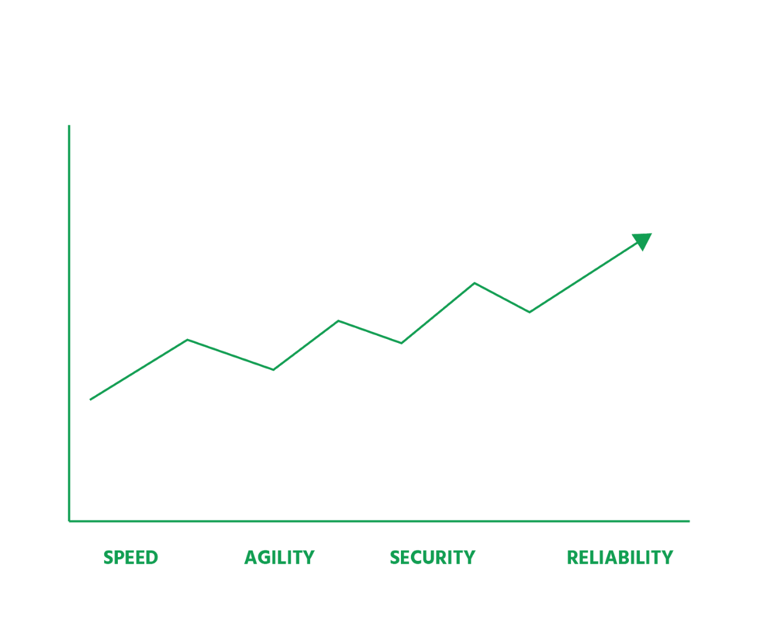

NSX Data Center helps organizations achieve the speed, agility, security, and reliability of the software-defined data center. It brings the benefits of compute virtualization to the whole data center, enabling entire networks to be created in software, and moved, copied, or deleted as easily as a virtual machine can be.

Every physical networking element and service in a traditional environment can be recreated in software – in seconds: logical switches, routers, firewalls, load balancers, and VPN, as needed.

It no longer takes weeks to provision today’s complex networking and security services, because NSX Data Center does this in minutes. Automation (in which individual tasks are programmed to run by themselves) and orchestration (which is the coordination and management of many automated tasks) greatly reduce the amount of time-consuming manual configuration that administrators need to do, which in turn greatly reduces the amount of costly human error.

Because virtual machines in an NSX Data Center interact with each other through the vSwitch, the number of east-west (i.e., server to server) hops (or devices that data must pass through en route to its destination) is reduced. Network traffic flows are simplified.

The NSX Data Center uses **Equal-Cost Multi-Path** routing (ECMP) in which up to eight active NSX Edge appliances can be deployed at the same time and which increases the amount of data that can be sent from one point to another in a set amount of time (the bandwidth) for north-south communication. physical to logical (traffic from outside world to the data centre) ECMP means that NSX virtualized networks will keep on working even if multiple devices fail at the same time, giving NSX data centers high availability.

When the NSX Data Center is used with vRealize Automation, an NSX app isolation policy acts as a firewall to block all inbound and outbound traffic to and from workloads. Workloads can then communicate with each other but cannot connect outside the firewall. Threats can, therefore, be contained and data breaches (each one currently costing over $3.5m on average globally) can be reduced.

With security policies attached to the applications they’re protecting, there’s no longer a need to spend large amounts on additional hardware and software to firewall east-west traffic inside the data center.

Whereas in traditional infrastructures, new physical servers had to be bought to increase capacity, the NSX Data Center can bridge two or more network clusters to use any spare capacity that’s already there. Existing server capacity is therefore used better, and money is saved. Further financial savings can be made in the underlying physical hardware that is still used to forward data (the underlay), as this can be off-the-shelf, industry-standard hardware. Expensive-to-buy and maintain vendor-specific hardware is no longer needed. And because the underlay has less to do, it should last longer; another cost-saving.

As discussed in section 5, vRealize Network Insight provides a 360° view of your entire NSX infrastructure. It is simple to use and makes it easy to access NSX activities and security events (records of security actions). In addition, vRealize Network Insight integrates with all major third-party network vendors.

## Integrating with Existing Network Infrastructure

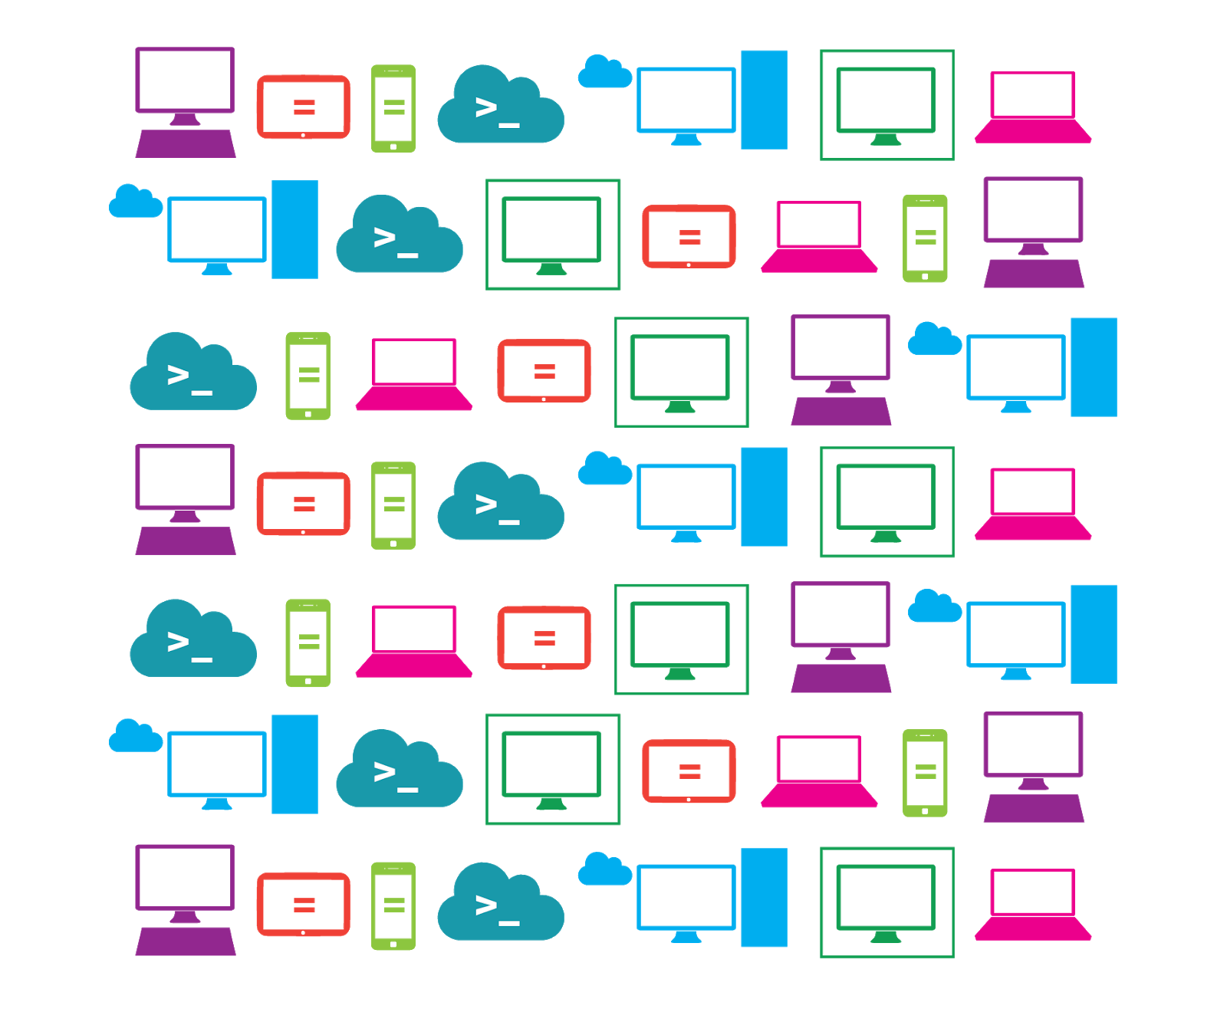

Administrators face persistent challenges as the demands placed on their networks by ubiquitous computing, the internet of things, voice over IP, and video over IP continue to grow. Capacity and security are two constant concerns; being able to monitor, manage, and troubleshoot multi-site networks (including different cloud environments) is another; the scalability of their infrastructures, compliance, advances in technology – the list goes on. Just keeping pace with these real and ever-present challenges can make the prospect of transitioning to a new networking model seem more daunting than it might actually be.

The NSX Data Center can be deployed without disruption to existing compute and networking infrastructure, applications, and security products because it works with them. It can be deployed over any existing network infrastructure and gives administrators the flexibility to virtualize as little or as much of their networks as they choose.

NSX provides networks that support any infrastructure, any compute platform, any application, any device, and any cloud.

The existing underlying physical network remains to handle packet forwarding but, once NSX Data Center is deployed, it barely needs to be touched and can, in fact, be streamlined. And if over time, parts of the physical network need to be replaced, any off-the-shelf, industry-standard hardware can be purchased, providing even more flexibility.

## NSX Architecture

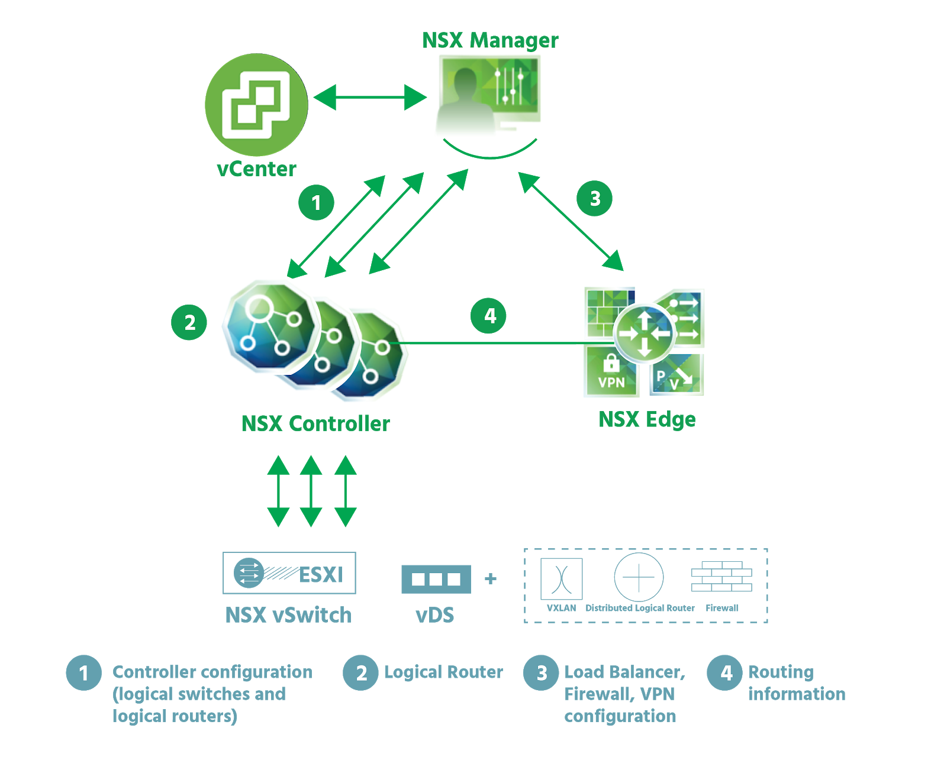

NSX offers a complete suite of simplified logical networking elements and services, including logical switches, routers, firewalls, load balancers, VPN, monitoring, security, and quality of service. (Quality of service or QoS manages packet loss, transmission delay, and other issues on a network.) These services are provisioned in virtual networks through any cloud management platform using NSX APIs.

To existing workloads, virtual networks operate exactly as physical networks do – there’s no difference. NSX distributes virtualized network and security services to each workload. Wherever workloads move, their services move with them.

NSX architecture consists of a data plane, control plane, and management plane. Each plane consists of multiple components, responsible for platform management, traffic control, and service delivery. The architecture also includes the necessary components for integration with a cloud management platform.

We will look at each of the three planes next.

Management Plane

The NSX-V management plane is built by **NSX Manager**, the centralized network management component of NSX. *NSX Manager* provides configuration and orchestration of logical switching and routing, the distributed firewall, networking, Edge services, and security services.

*NSX Manager* is installed as a virtual appliance on an ESXi host in a vSphere environment. There is a one *NSX Manager* per *vCenter Server Appliance*. (vCenter Server Appliance is the central point for configuring, provisioning, and managing virtualized data centers.)

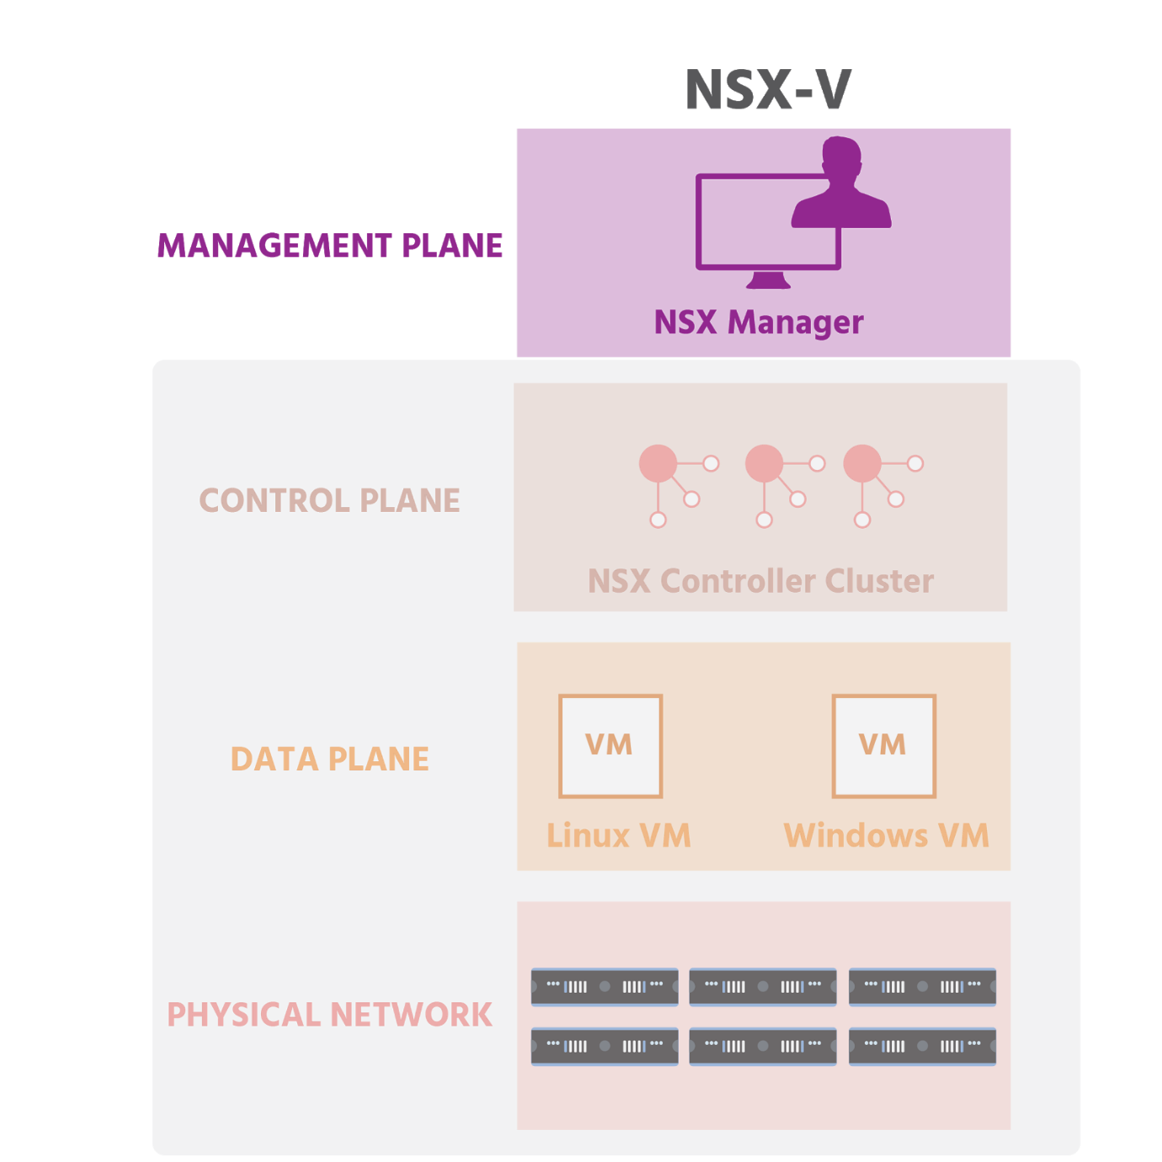

*NSX Manager* provides an overall view of a system. The single unified user interface allows you to manage both vSphere and NSX within the vSphere Client. (vSphere is the industry-leading virtualization and cloud platform and is made up of the ESXi hypervisor, vCenter Server, and vSphere Client; with vSphere Client, a web browser can be used to connect to remote desktops and applications.) For NSX-V, a networking and security plug-in for the vCenter Server user interface (UI) enables administrators to configure and control NSX.

*NSX Manager* is not only able to orchestrate *built-in* Edge services and security services, but also those of third-party vendors.

If REST APIs need to be used (if, for example, an administrator wants to request something that isn’t available via the graphical user interface – GUI – but needs to be requested directly from NSX; or if an administrator wants to use scripting to automate a task), this is done with *NSX Manager* and the administrator’s REST client (software).

A few of the many VMware and third-party products that NSX integrates seamlessly with include:

* *VMware vRealize Automation* which streamlines the provisioning process and keeps networking and security services in sync with applications
* *VMware vRealize Log Insight* which provides real-time log management (a log is a record system processes, events, and messages)
* *VMware vRealize Operations Manager* which uses data collected from system resources to identify issues and either suggests corrective actions or offer helpful analytical tools
* *VMware Integrated OpenStack* which is VMware-supported OpenStack distribution that makes it easy to run an enterprise-grade OpenStack cloud on top of VMware infrastructure (OpenStack is a free and open-source cloud operating system)
* *VMware vRealize Network Insight* which gives users a micro-segmented view of their applications and a 360-degree view of their physical and virtual networks
* *Tufin Orchestration Suite for Firewall Management* which enables users to visualize and control their network security policies across all on-premise environments and cloud platforms

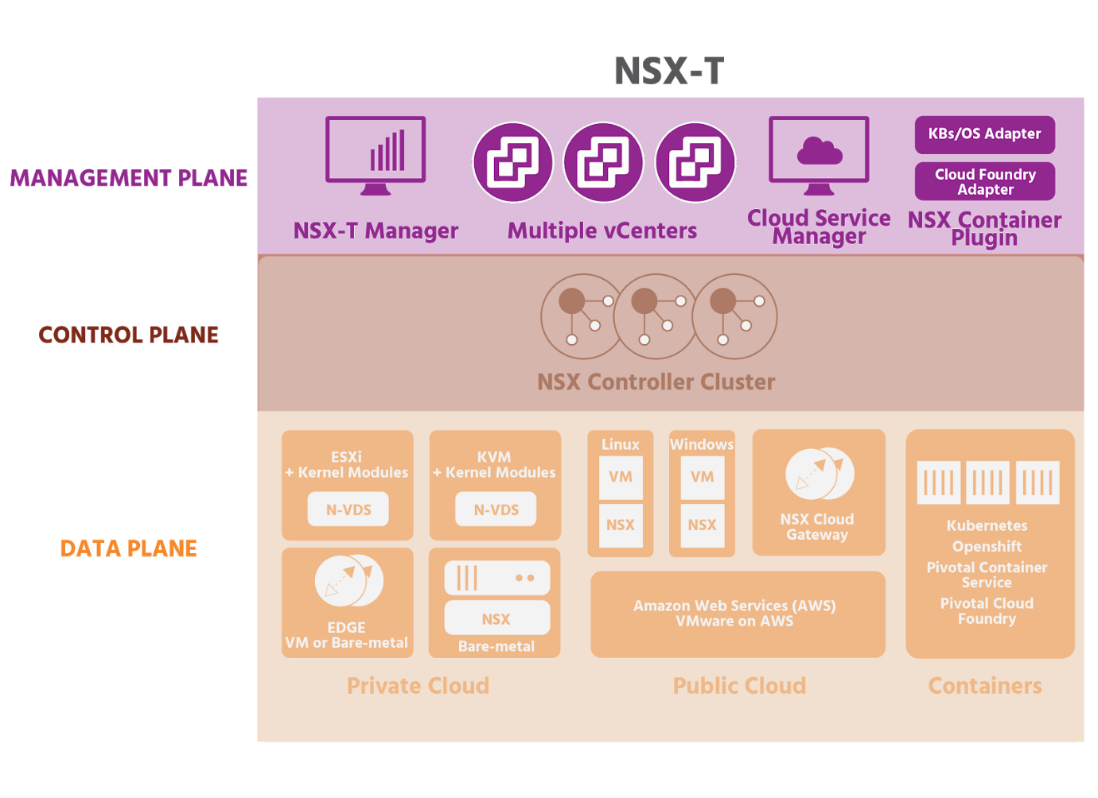

In a NSX-T Data Center, the management plane function and the central control plane function have been collapsed into a new management cluster to reduce the number of virtual appliances that need to be deployed and managed by the NSX administration. The NSX Manager appliance is available in three different sizes: a small appliance for lab or proof-of-concept deployments; a medium appliance for deployments to 64 hosts; and a large appliance for customers who deploy to a large-scale environment.

Control Plane

The control plane of NSX-V runs in the NSX Controller cluster. The *NSX Controller* serves as the central control point for all logical switches within a network, and maintains information about all hosts, logical switches, and distributed logical routers. Controllers distribute network information across all controllers in a cluster and are responsible for distributing network information to all the ESXi hosts. Controllers do not have any data plane traffic passing through them.

The controller cluster is responsible for managing the distributed switching and routing modules in the hypervisor.

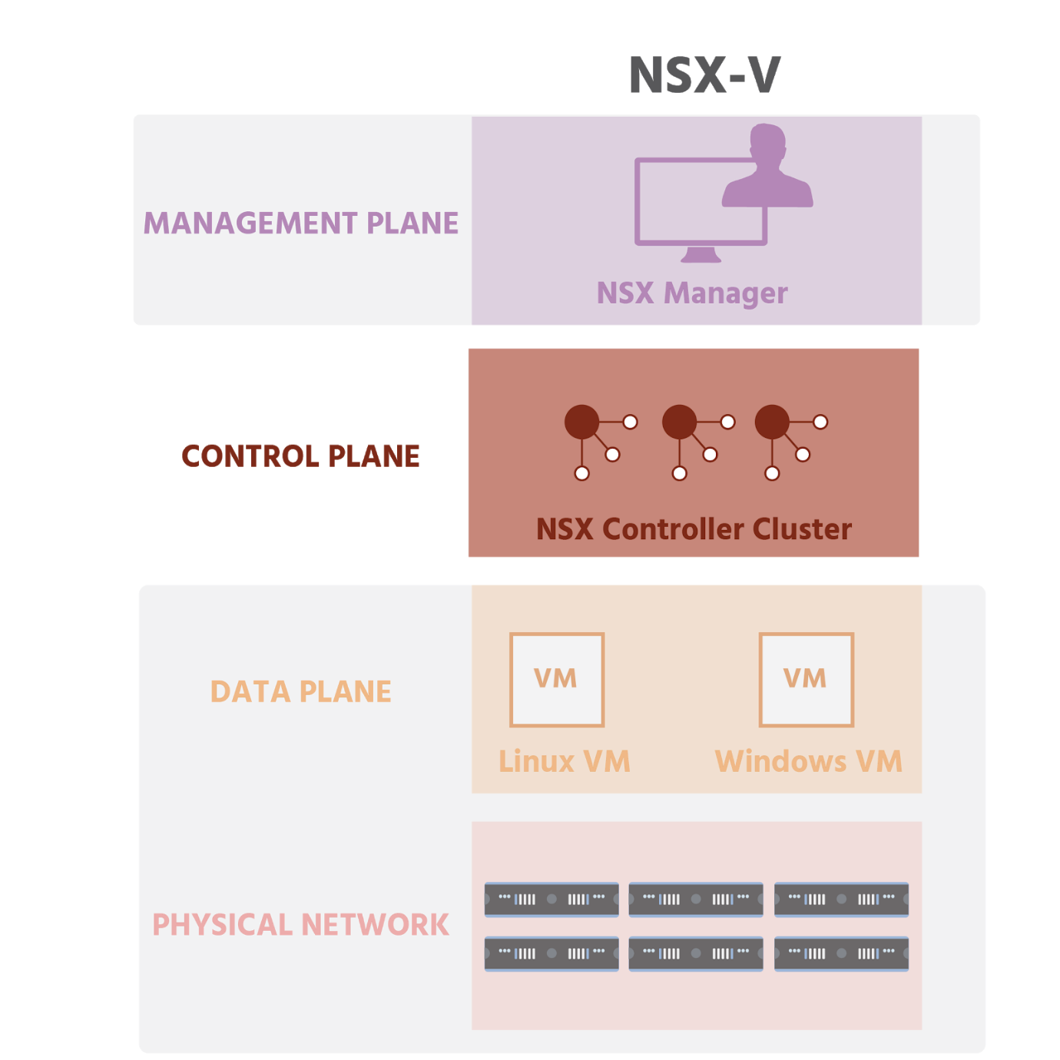

Network virtualization functions are distributed among the controllers. No matter the size of the *NSX Data Center* for vSphere deployment, a minimum of three *NSX Controller* nodes *must* be created in each NSX Controller cluster. In the event of a controller failure, the surviving controllers will assume the additional workload.

In NSX-T, whenever a *Distributed Logical Router (DLR)* is deployed, a *control VM* is automatically created. (With NSX-V, control VMs are optional - not created automatically - and are used for dynamic routing and Layer 2 bridging.) The control VM communicates with the NSX Controller cluster to ensure that the control plane has the most up-to-date routing table. The Controller cluster then programs the latest routing table on ESXi hosts through a *User World Agent (UWA)*. While the control VM does not itself route packets, it does make routing possible by the data plane:

* local forwarding within an ESXi host
* dynamic routing between ESXi hosts
* north-south routing provided by the Edge

UWAs pass virtual machine MAC addresses and IP addresses to *NSX Controllers*.

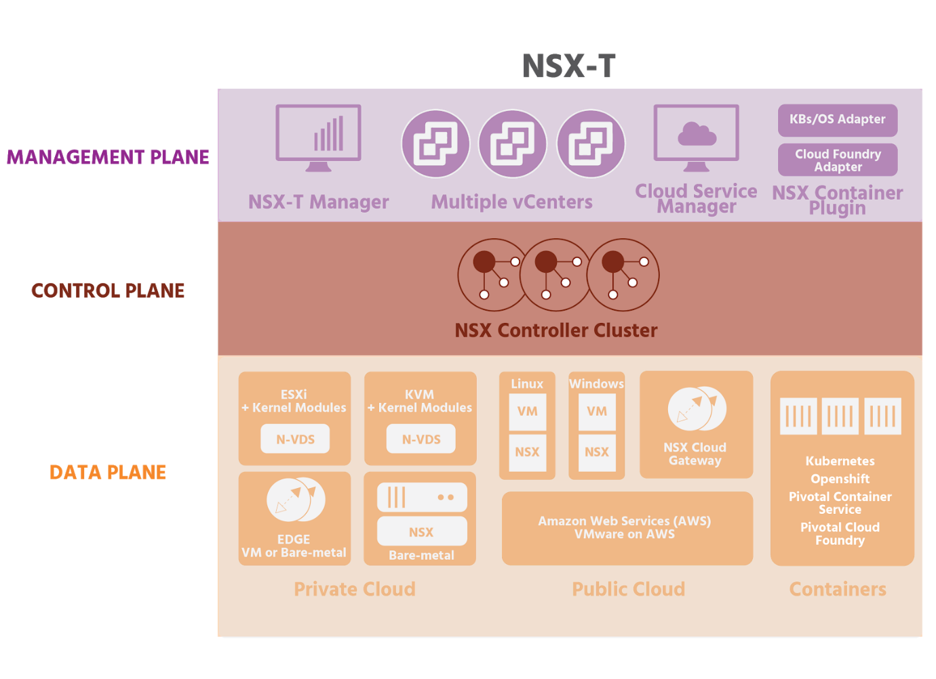

As mentioned in the last section, with NSX-T version 2.4, NSX Manager and NSX Controller have been combined.

Data Plane

The NSX data plane is where the actual network traffic flows. It consists of the NSX virtual switch, which is based on the **vSphere Distributed Switch** (*vDS*) with additional components to enable services. These add-on components include kernel modules that run within the hypervisor kernel, providing services including distributed routing, distributed firewall, and communication from the logical network to the physical network (e.g., overlay to VLAN bridging, either at Layer 2 as NSX bridging or at Layer 3 as NSX routing).

The *NSX vSwitch* abstracts the physical network and provides access-level switching (which connects end-user devices to the network) in the hypervisor. It is central to network virtualization because it enables logical networks that are independent of physical constructs.

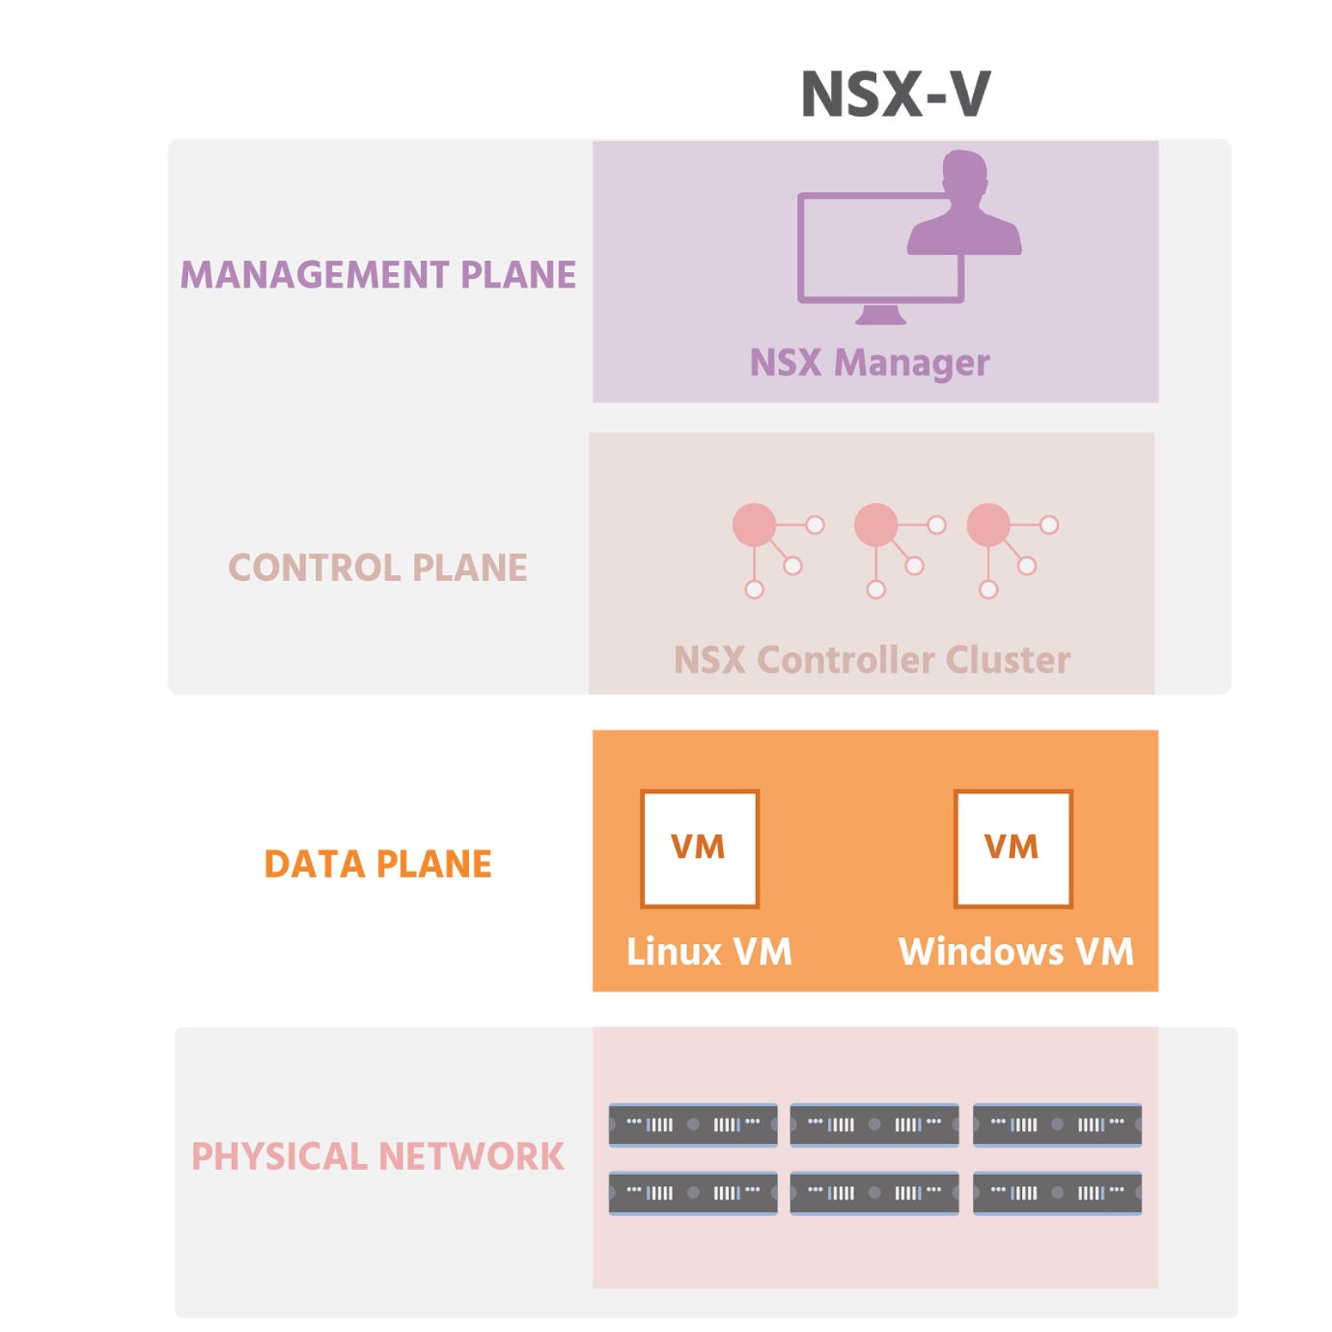

Logical switching enables an extension of a Layer 2 segment and IP subnets anywhere in the network, independent of the physical network design. Routing between IP subnets can be done in software without traffic leaving the hypervisor. Logical routing is performed directly in the hypervisor kernel. The **Distributed Logical Router** (*DLR*) provides the best path for the east-west traffic that flows within the virtual infrastructure.

NSX security enforcement is done directly at the kernel and vNIC level and includes:

* *Distributed firewall* for east-west Layer 2 to Layer 4 traffic
* *Edge firewall* for perimeter protection of north-south traffic
* *SpoofGuard* for validation of IP/MAC identity.

NSX also works well with security software from other vendors, including anti-virus/anti-malware/anti-bot products, file integrity monitoring, and vulnerability management of guest VMs. It provides traffic management, monitoring, and troubleshooting within a virtual network.

*NSX Edge* provides a centralized point for seamless integration with the physical network infrastructure to handle communication with the external network routing (north-south communication), as well as perimeter firewall protection.

NSX supports NAT and DHCP, and can perform Layer 4 to Layer 7 logical load balancing (in two modes: inline and proxy mode, as discussed in section 4.6.2).

NSX VPN services (Layer 2 VPN, IPsec VPN, and SSL VPN) interconnect remote data centers and user access.

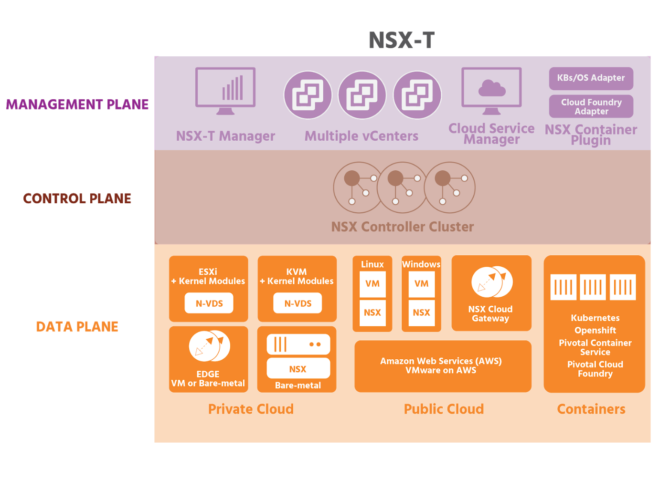

NSX can also be integrated with existing physical devices, including physical load balancers, firewalls, and monitoring devices.

## Security Features

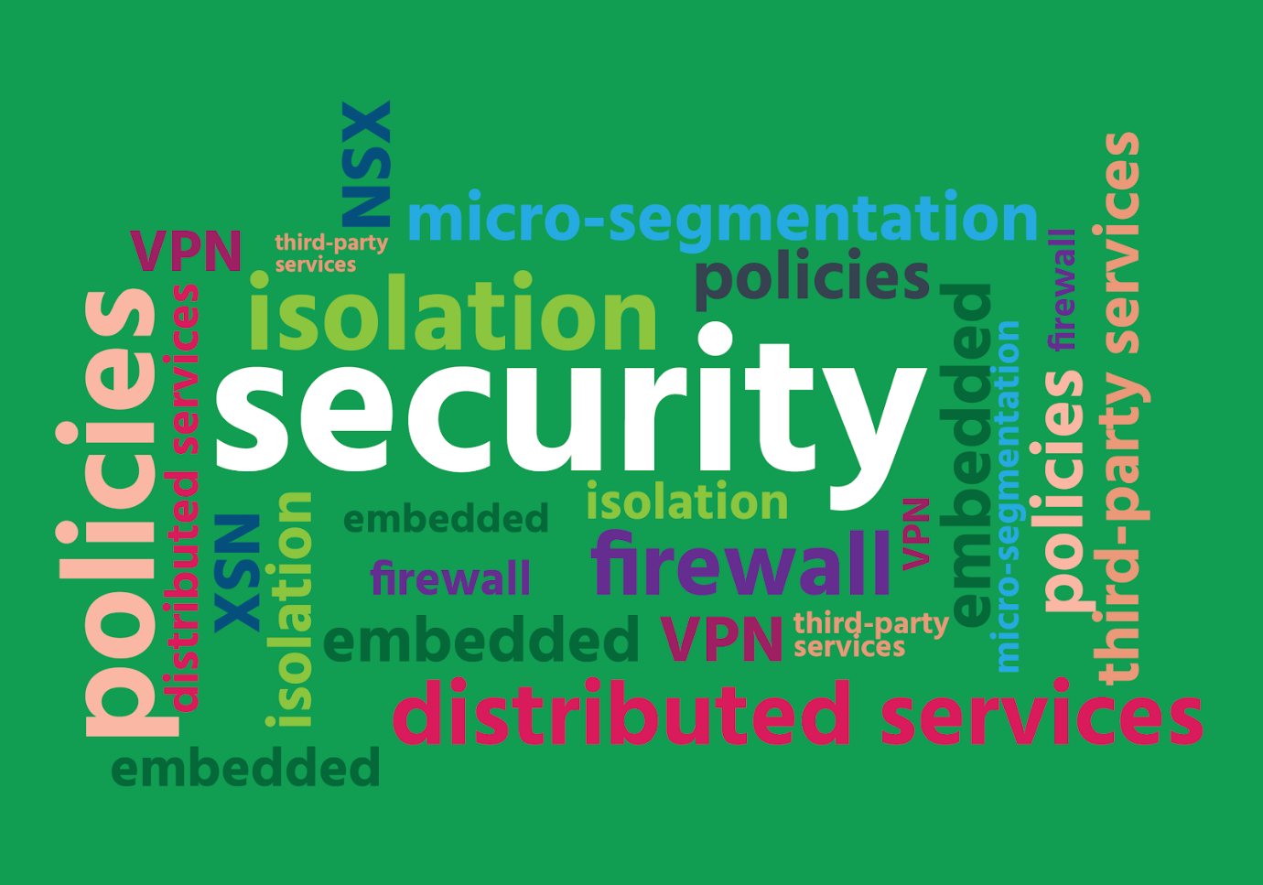

Traditional perimeter-centric firewall and intrusion detection and prevention systems cannot sufficiently protect the inside of a data center. There is limited (if any) isolation. Security controls within guest devices are not only vulnerable to attack but also drain resources and contribute to data congestion. Even if organizations are using the best-known security products, this sometimes only adds deployment and troubleshooting complexity to an already-complex job. Trying to get different products from different vendors to work together, especially without automation, can result in human error.

NSX provides unmatched security that’s built directly into the data center. With it, organizations can streamline their networking and security operations, and automate the deployment of logical networks, firewalls, load balancers, and many other networking features. It is a complete platform for advanced networking and security and, as a result of using it, over 7,500 businesses – 82% of the Fortune 100 - are deploying networking faster and adapting to changes more easily.

NSX embeds security functions directly into the hypervisor, providing micro-segmentation and automated, most-finely detailed (granular) security for every individual virtual desktop or device. This prevents threats from spreading in a data center, enabling a fundamentally more secure environment. NSX enables security policies to travel with specific workloads, wherever they are in the network and whenever they move.

Because virtual networks are isolated by default – isolated from each other and from the physical network that is their underlay – data centers deploying them are by definition, more secure.

A network will also include what’s known as a **Demilitarized Zone** (DMZ) or screened subnet. This is a physical or logical sub-network of the main network that’s positioned between external networks (e.g., the internet) and the main network. External networks can only connect with what is in the DMZ (such as web servers, email servers, file transfer protocol servers, and VOIP servers). The DMZ itself has limited access to the main network, which is protected behind one or more firewalls. The idea is that a hacker attack will not be able to penetrate into the main network, but will be contained within the DMZ. NSX can provide a logical DMZ anywhere in the data center, and, being software, it can be as large or as small as needed – from a single app to the whole data center.

NSX works seamlessly with third-party products, meaning that organizations can continue to use their preferred network security products without increasing the risks associated with manual configuration without automation.

## Micro-Segmentation

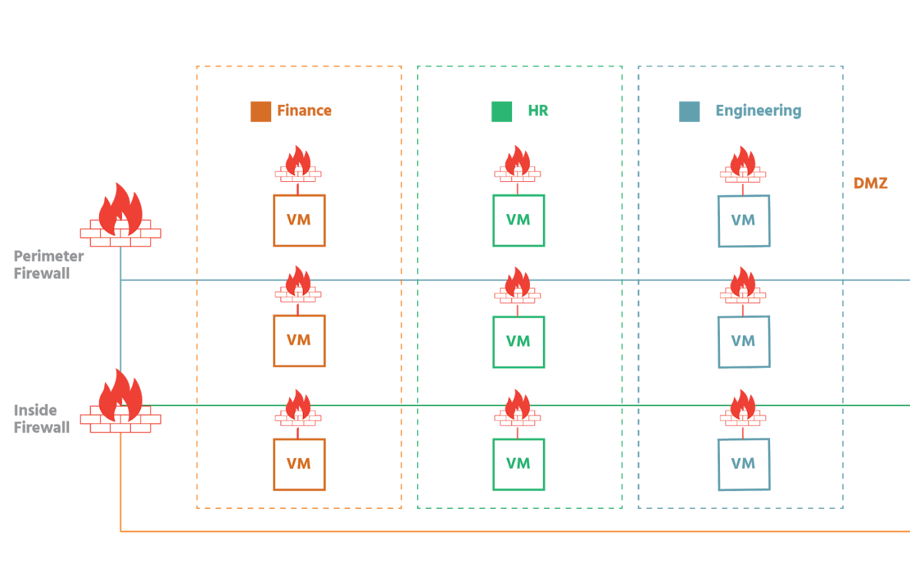

Network traffic patterns have shifted drastically in recent years from mainly north-south (traveling from outside the data center perimeter to a server inside and then back) to east-west (traveling laterally between servers inside the data center perimeter). East-west traffic is in fact now thought to account for up to 80% of all network traffic. This significantly increased lateral traffic often never passes through firewall controls. The need for zero trust has, therefore, never been greater. Zero-trust is an approach to network security (introduced by the technology market research company, Forrester, in 2010) that allows no traffic to move in within or in and out of a data center without first having its identity strictly verified based on user and location.

Network security teams have been trying to achieve the level of east-west security that micro-segmentation provides for years. The problem has been that implementing micro-segmentation on a large enough scale has been impossible. Even if a security team was somehow able to afford enough firewalls to inspect all east-west traffic, there's no way the team would be able to keep up with the rule management as new workloads were created, moved, and retired. And even with host-based firewalls running on the operating system of individual virtual machines (as has been popular over the last few years), determined hackers have simply disabled those firewalls, leaving the whole network exposed.

With NSX, the distributed firewall runs inside the kernel of the ESXi host- not in the operating system (OS). Micro-segmentation further simplifies network security. At its most basic, micro-segmentation is the ability to segment elements of a system into extremely granular components. The value of this lies in the fact that, once a network is segmented, security policies can easily be applied, whether an administrator wants to target a cluster of servers or a single VM.

To micro-segment a network, an administrator first creates logical groups called **security groups**. Security groups are containers that can contain multiple object types, including VMs, logical switches, vNICs, and **IPsets**. (IPsets store IP addresses, MAC addresses, and port numbers, among other things). Security tags (which are labels that can be attached to a VM), VM names and logical switch names can be used to add objects to security groups. For example, all VMs with the security tag web would automatically be added to a specific security group for web servers. Once the security groups have been created, the administrator creates the necessary security policies. The security policies are then applied to the appropriate security groups.

Each VM can now be on its own perimeter – have its own firewall. The security policies defined for it will go with it wherever and whenever it moves. Its security is no longer dependent on an OS-based firewall that could be disabled, making the VM the launch-point for a system-wide attack. Neither is the VM solely reliant on a physical firewall for its protection, in which scenario traffic leaves the VM, travels to the firewall for inspection, and is then either stopped or allowed to flow depending on the policy-settings. With the firewall now running in the kernel of the ESXi host, when VM1 wants to send data to VM2, the data is inspected when it reaches the vNIC of VM2.

Virtual networks are isolated by default- from each other and from the underlying physical network- and this provides an immediate security boost since a problem with one virtual network is contained to that one network. It will not spread.

Attackers can modify IP addresses to gain access to networks. NSX policies go beyond using IP addresses, taking into consideration the VM, the virtual network, the operating system, and more- streamlining configuration and reducing errors at the same time.

As mentioned in the last section, NSX works seamlessly with the best known security products. Administrators can, therefore, continue using their existing security products from vendors such as Palo Alto Networks, Trend Micro, Symantec, McAfee, and Rapid 7. On NSX, these security products use security tags to share security information in order to adapt to changing security conditions.

With the increasing adoption of the software-defined data center and network virtualization with NSX, micro-segmentation has become both operationally possible and economically practical for businesses. Administrators can directly target lateral east-west traffic traveling between VMs inside a data center. This makes NSX ideal for securing intra-data center network traffic, for fully isolating different networks (for example, for highly sensitive workloads) and for simplifying networks that would otherwise require complex access policies.

## Secure End-User

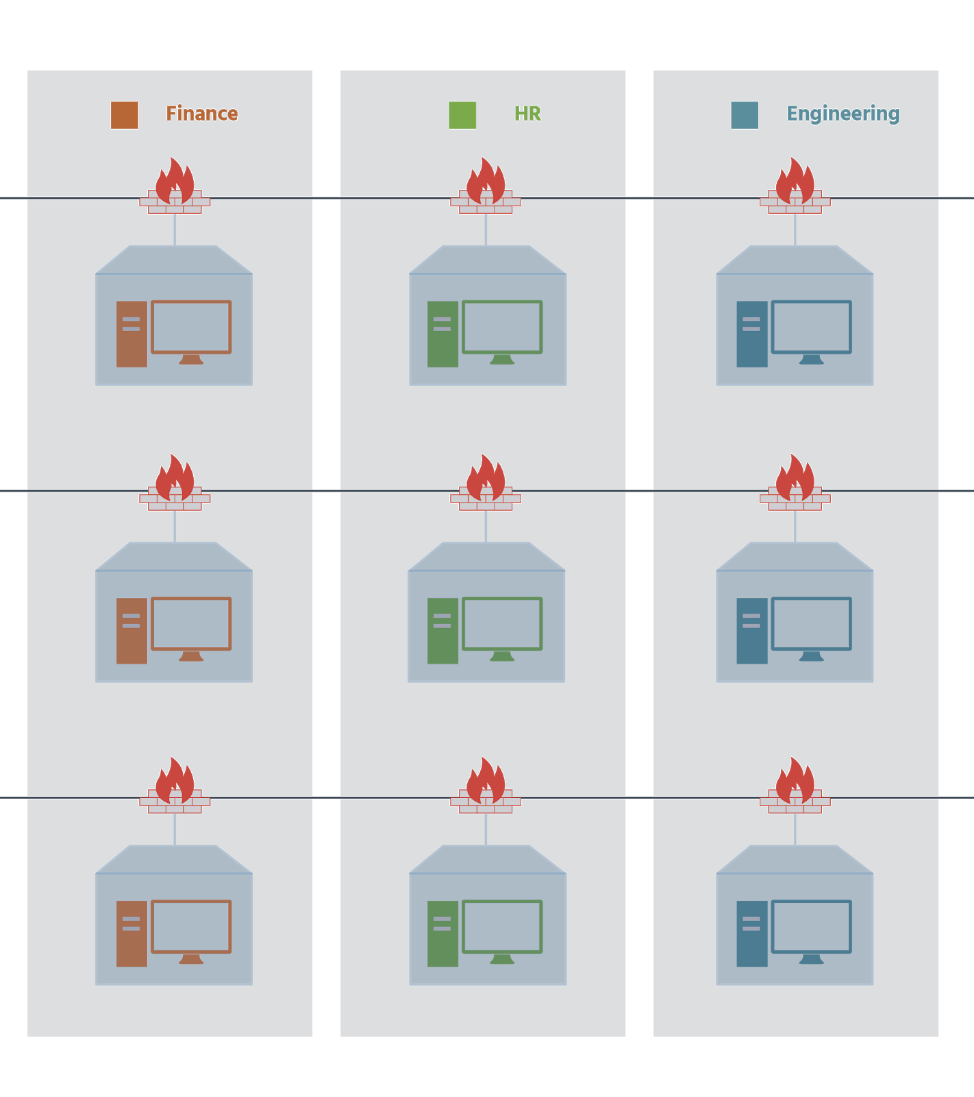

Many enterprises have deployed Virtual Desktop Infrastructure (VDI) to take advantage of virtualization technologies beyond the data center. VDI is the technology that’s used to provide and manage virtual desktops. VDI hosts desktop environments on a centralized server, and users connected to the network can access these virtual desktops from anywhere and any device.

Unfortunately managing groups of virtual desktop users is often a complicated process involving multiple teams. This is particularly complex in organizations with different user groups, each group having its own level of access to various resources.

NSX simplifies VDI by providing security based on logical groups of users or departments. This means that organizations are able to speed the deployment of virtual desktop environments and use their resources more efficiently. Security is no longer constrained or defined by the network topology.

NSX micro-segmentation integrates network and security with VDI management, allowing for the creation of a single set of policies for as many different VDI users as necessary. Micro-segmentation of user environments also means that NSX is able to secure traffic between virtual desktops and adjacent workloads – a risk that many organizations are unaware of. With NSX, if one end-user’s virtual desktop is attacked, the breach can easily be contained to just that user.

The automated application of network and security policies, and the fact that these policies seamlessly integrate with anti-virus and next-generation firewall vendors further simplify VDI for administrators.

The net value of this fundamental shift in networking and security is that businesses are able to provide a dramatically more secure infrastructure and do it in a way that’s significantly cheaper than traditional approaches (at ⅓ of the cost), and much simpler to provide.

# Virtual networking components [Section 4.1](https://content.netdevgroup.com/contents/net-virt-concepts/jtqyMqtpuo/4.1) | [Section 4.2](https://content.netdevgroup.com/contents/net-virt-concepts/jtqyMqtpuo/4.2) | [Section 4.3](https://content.netdevgroup.com/contents/net-virt-concepts/jtqyMqtpuo/4.3) | [Section 4.6](https://content.netdevgroup.com/contents/net-virt-concepts/jtqyMqtpuo/4.6) | [Section 4.6.1](https://content.netdevgroup.com/contents/net-virt-concepts/jtqyMqtpuo/4.6.1) | [Section 4.7](https://content.netdevgroup.com/contents/net-virt-concepts/jtqyMqtpuo/4.7) | [Section 4.7.1](https://content.netdevgroup.com/contents/net-virt-concepts/jtqyMqtpuo/4.7.1)

# **Module 6: Where To Go From Here?**